
Faculty of Engineering & Digital
Technologies
Department of
Computer Science,
Artificial Intelligence and Electronics

Security Assessment of Chatbot Applications

Final Project Report
Abdullah Sajjad
22006891

A thesis submitted in part fulfilment of the degree of BEng (Hons) Computer Science for Cyber Security

Supervisor: Dr. Kulvinder Panesar

30th January 2025

Declaration

The candidate confirms that the work submitted is his own and that appropriate credit has been given where reference has been made to the work of others. The candidate agrees that this report can be electronically checked for plagiarism.

Abdullah Sajjad

Acknowledgements
I would like to extend my sincere gratitude to my supervisor Dr Kulvinder Panesar for her guidance and mentorship throughout this challenging academic year. She has provided me with constant aid throughout this journey and has aided me in producing my best work for the Security Assessment of chatbot platforms.
I would also like to thank Daniel Neagu for his constant guidance throughout this project, providing insightful lectures which played a significant role in shaping the direction of this project. I would also like to thank him for his inspiring lectures drawn from students from previous years and webinars which have motivated me to strive for excellence, making sure I graduate with a successful degree.

Abstract
The final part of this project will be centred around completing extensive tests on the Rasa chatbot, with the sole purpose of identifying common vulnerabilities and weaknesses within their applications and, thereafter, providing guidance to mitigate the likelihood of the identified threats to chatbot systems.
In order to complete this successfully, comprehensive research will be undertaken to deepen our understanding of the key concepts and techniques integrated within chatbot applications. The research will aim to cover key concepts within Chatbot applications such as The Legislation of Chatbots, The Architecture of Chatbots, and Social, Ethical and Legal issues within Chatbot Applications. This will lay the foundational knowledge, allowing for a more effective and impactful implementation of this project.
Regarding the implementation of this project, this project aims to perform penetration testing and vulnerability assessments on various chatbot platforms using OWASP methodologies to test for the most prevalent vulnerabilities within chatbot platforms. The design and implementation section of this project will significantly impact the Digital Sector as it will equip organizations and developers with valuable insights into elevating their chatbot security, ultimately leading to the development of bulletproof chatbots that will enhance their user protection.
Additional security guidelines and advice will be discussed and explained within this report.

Table of Contents
Acknowledgements 3
Abstract 4
1. Introduction 7
1.1 The rise of Chatbots 7
1.2 The Benefits of this Project 8
1.3 Problem statement 9
1.4 Aims and Objectives 9
1.5 Novelty & Challenges 10
1.6 Programme Alignment 11
1.7 Summery of report 12
2.Literature Review 12
2.1 History of Chatbots 12
2.1.1 The Features of Chatbots 14
2.2 Common vulnerabilities within Chatbots 16
2.3 Legislation of Chatbots 21
2.4 Chatbot Platforms 22
2.4.1 Rasa Platform 23
2.4.2 Botpress Platform 25
2.5 System Architecture of Chatbots 26
2.6 Social, Legal, Ethical Issues 28
2.7 OWSAP 30
3 Requirements & Analysis 33
3.1 Functional & Non-Functional Requirements 34
3.2 Associated Diagrams 35
4 Design and Implementation 40
4.1 Implementation of Rasa Chatbot 40
43
4.2 Test 1 – OWASP Injection Test 44
4.3 Test 2 –OWASP Broken Access Control Test 49
4.4 Test 3 – OWASP Security Misconfiguration Test 53
4.5 Test 4 – OWASP Cryptographic Failures Test 59
5 Conclusion and Future work 64
5.1 Conclusion 64
5.2 Future work 65
6. References 67
7. Appendices 68
Appendix 70
Ethics Checklist 70

Introduction

In recent years within technology, we have witnessed the rapid growth of Artificial Intelligence which has given birth to technology platforms such as chatbots, Image Recognition, and Virtual assistants. Among these, chatbots have experienced a remarkable 92% increase in usage since 2019 (Vyshnevska, 2023), which has been driven by the growing demand for automation in customer service and various businesses globally. This surge in the adoption of chatbots reflects the technological advancements in AI and machine learning, which enable chatbots to engage more effectively with users.
Chatbots’ ability to handle large volumes of queries simultaneously has led to many users and businesses interacting with and utilizing these chatbot applications. AI chatbots benefit businesses significantly as they save valuable time and resources thus reducing costs whilst increasing their businesses productivity and customer satisfaction/ loyalty. Within the business sector, the use of chatbots is mostly used in healthcare, real estate, and finance (Anoushka Chopra, 2019) which emphasises how chatbots have become a central part of these sectors’ communication channels, facilitating customer service and other key interactions. Specifically for these sectors chatbots have become a central part of the business’s operations and purpose due to their effectiveness, reliability, and ability to communicate with customers seamlessly.
Through the integration of Natural Language Processing (NLP) as well as machine learning algorithms, chatbots excel at effectively understanding, interpreting, and responding to humans successfully. Natural Language Processing enables chatbots to consider the meaning of the user’s language, which allows for more accurate and contextualised conversation, resulting in an increase in customer satisfaction when handling complex queries.
However, as the use of chatbots continues to rise, so do the security concerns due to their increased vulnerability to cyber-attacks such as SQL injection attacks and phishing attacks. This project will aim to identify common vulnerabilities within chatbot applications using OWASP Top 10 to aid in mitigating cyber security threats in chatbot systems. The goal is to provide users access to safer, more secure chatbots that protect users and businesses from potential cyber-attacks.

The rise of Chatbots

In today’s day and age artificial intelligence chatbots are commonly used globally as they have revolutionized how businesses communicate with customers by providing intelligent, resource saving solutions. AI chatbots have introduced an innovative approach for businesses to communicate with customers as it stresses the importance of customer service and allows for all customer problems and questions to be solved without the need for staff intervention. Through a recent study gathered online it is believed that 90% of chatbot users’ experiences are positive or neutral (UMNI. (2022)), which highlights the positive impact of chatbots on users and businesses.
With the invention of AI chatbots, several businesses across industries have greatly benefited from their 24/7 availability, which enables the handling of customers' inquiries immediately without delays, hence increasing customer satisfaction. Besides that, chatbots have developed the ability to deliver valuable information regarding customers' preferences and behaviours to businesses by allowing them to tailor their offerings towards better meeting customers' needs. Overall, the use of chatbots will continue to rise globally due to the value it provides businesses in enhancing customer experience whilst ensuring business efficiency and productivity.

1.2 The Benefits of this Project

This project provides numerous benefits for all stakeholders of chatbot platforms. One of the main benefits of this project is its ability to enhance chatbot security. This is of the utmost importance for organizations globally as it identifies potential vulnerabilities such as SQL injection attacks, phishing attacks, and cross-site-scripting attacks, consequently reducing the occurrence of them. As a result of this, organizations benefit as user’s data and information is protected and safeguarded through the compliance of GDPR and HIPAA regulations, ensuring data breaches and financial risks are minimised.
A further benefit this project provides for organizations is its capacity to improve business operations. This is because chatbot applications effectively boosts the customer service of organizations, ensuring user’s requirements are exceeded. As a result of this, the brand reputation of the organization increases dramatically due to the increase in customer confidence, which ultimately increases the competitiveness of the organization in its respected market.
One of the most impactful benefits this project provides is its valuable insights into chatbot security, contributing to enhancing chatbot technologies functionalities and frameworks. From this, developers and organizations will be provided with accurate guidelines on implementing strategic techniques to effectively reduce the risk of external attacks. As a result of this, chatbot applications will be enhanced effectively, elevating their security posture, ultimately making them a powerful tool that can be utilised by many sectors globally.
Overall, this project will play a vital part in addressing growing security concerns in AI-driven chatbot systems. By identifying common vulnerabilities, assessing compliance with regulations, and recommending security guidelines, it plays a vital role in enhancing an organization’s operations, and safeguarding user’s data in an increasingly dynamic digital world.

Problem statement

As the use of AI chatbots continues to rapidly grow and play a critical role globally within businesses, their security has become an increasing concern. Despite their numerous benefits, there is a rapid growth in the vulnerabilities within these chatbots through cyber-attacks such as SQL injection attacks, user authentication attacks, and phishing attacks.
To address these concerns, this project will research various open source chatbot platforms, identifying their security and vulnerability features as well as their operational processes. Additionally, it will integrate the OWASP framework to assess the security of the Rasa chatbot platform, focusing on identifying common strengths and weaknesses in its security deployment.
The overall goal of this project is to improve the security implementation of AI chatbots by maximising OWASP’s guidelines, consequently reducing the risk of data breaches. This will allow AI powered chatbots to become a more secure platform for users and businesses to maximise.

1.4 Aims and Objectives

As the use of AI chatbots grows it is clear that there is a concerning rise of vulnerabilities and weaknesses within these applications that this project will aim to address. Through an in-depth study of various chatbot platforms, chatbot architecture, and the social, legal, and ethical issues, it will lay the foundations for providing guidelines and recommendations to developers in implementing the best practices to elevate the defensive security of chatbot platforms.
• To research the most commonly used open source chatbot platforms such as Rasa Talk, Botpress, and various other platforms, with the sole objective of identifying common security features as well as vulnerabilities within these systems.
• To evaluate at least 5 of the most common vulnerabilities within chatbot platforms particularly focusing on the authentication measures, data encryption, and access control of chatbot applications, allowing to address common vulnerabilities within these systems and determine how to mitigate these threats.
• To compile a literature review using over 10 research papers, analysing the various chosen open-source platforms which will allow us to critically evaluate the main functions of the chatbot and its system architecture.
• To assess the compliance of these chatbot platforms with regulatory standards such as GDPR and HIPAA.
• To design and implement testing techniques using OWASP top 10 to perform penetration testing and vulnerability assessments on a Rasa chatbot platform for the final prototype, which will allow for more secure chatbot platforms and allows to alter security protocols in case of cyber-attacks.
• To compile a list of at least 5 recommendations and guidelines for users and developers illustrating how chatbot platforms can become more reliant, secure, and safe.
Completing each of these aims, will allow this project to improve the overall security posture of chatbot applications, elevating the value of chatbots in the world of technology.

1.5 Novelty & Challenges

Since the development of AI chatbots, there have been numerous benefits that they have provided users and businesses globally. One of the core features of chatbots is their incorporation of Natural Language Processing and machine learning algorithms, to engage in human-like conversations. This innovative system has benefited the technology world massively as it provides chatbots with the ability to retain information, understand the tone when conversing, and remember the context of conversations.
Beyond the incorporation of NLP and machine learning algorithms, chatbots serve as a significant tool for responding and providing solutions to customer inquiries. Particularly within e-commerce and business sectors like Economics and Finance chatbots can be used to process customer orders or perform tasks such as booking customer meetings, without the need for human intervention. From research gathered online it is believed that companies that offer an excellent customer experience grow revenues 4%-8% faster than their markets (Fokina, 2024), which emphasises how critical the role of chatbots is in today’s world in boosting business profits, market growth, and their customer satisfaction. Ultimately, chatbots will continue to benefit business sectors globally by becoming the central component of their operation and communication channels allowing the business to continue to become successful.
However, despite the many benefits chatbots have provided various business sectors, there has been an increase in the vulnerabilities and weaknesses within chatbot applications that must be addressed. One of the main concerns that arise when using chatbot applications is the concealment of user’s data, ensuring no unauthorised access into these applications from attackers. Additionally, it is essential for developers to use data encryption techniques and ensure there are significant methods that are implemented within the system to authenticate users, which will automatically reduce the vulnerabilities within the system.
Furthermore, as the use of chatbot applications continues to rise significantly, we find there is a direct increase in the number of attacks on these platforms such as phishing attacks, man in the middle attacks, and even SQL injection attacks. This a growing concern as it highlights the security vulnerabilities within chatbot systems which make them more targetable to cyber criminals. These attacks can prove to be devastating for business reputation and customer satisfaction levels which highlights the need for these vulnerabilities to be addressed, thereafter designing solutions to help mitigate the threat of cyber-attacks.
This project will aim to address these challenges that have been listed above, by providing security guidelines, aiding developers in making chatbot systems more secure and safe.

1.6 Programme Alignment

Some of the learning outcomes of the Cyber Security program will be to develop a systematic understanding of the fundamental concepts and theories of computer science which includes detailed knowledge of hardware, computer architecture, and communication technologies. This is a significant aspect that must be covered within this project as it is important to understand how chatbots communicate over networks, thereafter, analysing security flaws within chatbot platforms.
Furthermore, this program requires Cyber Security tools to be implemented which will be reflected within this project through the integration of OWASP frameworks and penetration testing tools to stimulate attacks. To add to this, this project must cover the strategies that can be implemented to protect against cybercrime detailing the most common cyber-attacks on chatbot platforms whilst equally detailing the techniques that can be implemented to mitigate these threats.
Another learning outcome this project must cover is its ability to understand the use of appropriate cryptographic primitives. This involves evaluating the use of encryption and authentication tools within chatbot technology and recommending the best security practices for secure chatbot communication. In addition to this, this project must also analyse security issues and apply key computing concepts. This will involve identifying vulnerabilities within chatbot architecture, exploring ethical and legal issues, and measuring chatbot’s compliance with GDPR and HIPAA regulations. Finally, this project must demonstrate professional interest and expertise for a variety of careers. This will be accomplished through this project as it will be relevant to various careers such as Cyber Security, IT consultants, and Software Developers.
In conclusion, this project will meet all the learning outcomes of the Cyber Security program, ensuring key concepts within chatbot technology are evaluated, performing defensive strategies to mitigate threats using tools like OWASP, evaluating encryption techniques, and legal compliance. By doing so, it will establish a successful project that is relevant to various sectors within Computer Science.

1.7 Summery of report

Chapter 1: Introduction, which explains the ideology of this project, its aims and objectives, and the benefits of this project in the field of AI and Cyber Security.
Chapter 2: Literature Review, where various concepts within chatbot technology such as its architecture, and the legal, ethical, and social issues regarding chatbots are detailed. This section will also detail the security of chatbot platforms, their vulnerabilities, and their functionalities.
Chapter 3: Project Requirements & Diagrams – This chapter outlines the functional and non-functional requirements of this project. It also includes visual diagrams that help visualise the system architecture of the chatbot system.
Chapter 4: Design and Implementation (Testing) – This chapter includes the design and implementation of the test environment using Rasa detailing the files and commands that were used to create a chatbot for a hotel booking system. It will also include the integration of the OWASP framework and will detail the results of the various tests.
Chapter 5: A chapter summarising the outcomes of the project and reflecting on the journey of completing the project. It will also suggest some ideas for future developments to enhance AI chatbot security further.

2.Literature Review

In this chapter, we will discuss the literature on chatbot technology. We will discuss the functionality of chatbots, their compliance with legislations, and the common vulnerabilities within chatbot platforms. We will then choose multiple chatbot platforms and produce in-depth research into their specific functionalities and how they operate thereafter, discussing their system architecture. This section aims to increase our knowledge of chatbot platforms allowing us to understand how they operate and function before performing various security assessments in a later stage of this thesis.

2.1 History of Chatbots

The beginning of development of chatbots began in the 1950s when Alan Turing proposed an approach for evaluating computer intelligence which can be referred to as instant messaging. (Codecademy, n.d.). The proposed idea of Turing is considered a generative idea for chatbots. The first chatbot ELIZA was constructed in 1966. ELIZA simulated a psychotherapist’s operation, returning the user’s sentences in the interrogative form (Weizenbaum, 1966). Its ability to communicate was limited, but it was a source of inspiration for the subsequent development of other chatbots (Klopfenstein et al., 2017). (Adamopoulou and Moussiades, 2020).
Artificial intelligence was introduced in 1988 by Jabberwacky who constructed the basics of Chatbots written in Clever Script. Clever Script is a language that helps contextualise patterns based on previous discussions which is one of the main attributes of chatbots today. (Adamopoulou and Moussiades, 2020).
In 1991 the concept of a chatbot was discussed for the first time based on a chatterbot whose primary function was to chat. (Adamopoulou and Moussiades, 2020). Years later in 1995, the invention of ALICE (Artificial linguistic Internet computer identity) came to light inspired by Eliza (Wallace, 2009). ALICE was centred around pattern matching and the ability to discuss on the web regardless of the topic. However, the weaknesses of ALICE were that it was not integrated with human-like answers or intelligent features. (Adamopoulou and Moussiades, 2020).
The real breakthrough within the development of AI chatbots came in 2001 through the invention of SmarterChild (Molnár & Zoltán, 2018), which essentially aided American users with daily tasks saving them time as it executed tasks through the retrieving of data from databases. (Adamopoulou and Moussiades, 2020).
In the next decades within technology, there was continuous improvement in regard to the development of AI chatbots. From the creation of personal voice assistants such as Siri, Alexa, and Watson to the implementation of chatbots for Social Media Platforms, enabling customers to converse with developers and perform tasks. (Adamopoulou and Moussiades, 2020). Siri integrates natural language processing and machine learning techniques allowing us to understand and respond to user requests. (Wang, 2024). The next breakthrough within Artificial Intelligence was the creation of ChatGPT which is widely used today globally. This system is integrated with machine learning algorithms, which provide the system chatbot to stimulate human-like conversation and respond immediately. (Wang, 2024).

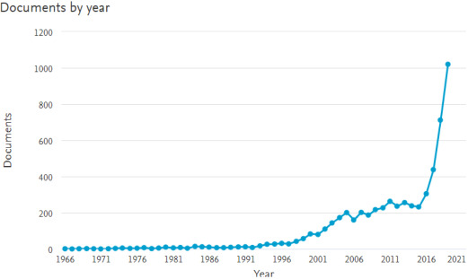
Figure 1 - The rise in the usage of chatbots, (Adamopoulou and Moussiades, 2020)

Figure 1 clearly demonstrates the rapid increase in the usage of chatbots particularly after 2016. From the figure above we learn how integral chatbots have become to numerous sectors, particularly within the Finance, E-commerce, and healthcare sectors. This transformation has been caused by the gradual improvement of AI chatbots since the 1950s as well as the rapid technological evolution in recent years, serving as a priceless asset to the business world.

2.1.1 The Features of Chatbots

AI chatbots have unique features that make them highly valuable to users and businesses, whilst being integrated with core functionalities that allow them to perform successfully. One of the most fundamental features within chatbot platforms is Natural Language Processing which “examines how computer systems can interpret and control the natural language regarding text or speech”. (Adamopoulou and Moussiades, 2020). Through the use of NLP, information from the user is gathered and analysed allowing users to be responded to immediately through the accurate execution of their requests. Furthermore, through the integration of NLP, it allows previous user interaction to be recalled whilst contextualising users’ input thus creating a more organic human-like interaction. (Adamopoulou and Moussiades, 2020). Specifically, within the customer service, Finance, and business sectors we find that the utilization of chatbots provides huge benefits as a result of the NLP feature within chatbots. The integration of NLP allows a large number of queries to be analysed simultaneously, whilst providing accurate responses, which allows resources and staff workload to be eased. As well as this, chatbots provide personalised recommendations to users which increases the customer satisfaction and brand image of the business. (Wang, 2024).
To further enhance the functionality of AI chatbots, the incorporation of Artificial Neural Networks (ANN) can be seen as essential. The use of ANN allows the chatbot system to take user input, derive its vector representation, and feed it as a feature to the neutral network which produces a relevant response. (Adamopoulou and Moussiades, 2020). The use of ANN allows users’ conversations to be personalized and contextualised allowing them to engage in coherent dialogue with users. Within the development of chatbots data driven learning can be viewed as a fundamental concept as it can elevate the effectiveness and efficiency of user conversation. One of the core abilities of data-driven learning is to analyse large amounts of data simultaneously to provide accurate responses to user’s requests and improve their conversational abilities. Additionally, data-driven learning can allow for a better understanding of users’ requests, preferences, and behaviours thus allowing users’ needs to be fulfilled accurately. (Izadi and Forouzanfar, 2024).
Large Language Models (LLMs) have become a fundamental aspect of AI chatbots as they have revolutionized the communication of chatbots. As a by-product of LLMs, transformer models used in chatbots allows for multiple sentences from user requests to be analysed simultaneously allowing for a significant improvement in the response time to user requests. (Izadi and Forouzanfar, 2024). The fundamental concept behind the use of transformers within chatbots is the attention mechanism which essentially allows the system to analyse each word and categorize its importance, thereafter, producing an appropriate response. To summarise LLMs consumption allows for a better understanding of user input by analysing users’ intent behind their queries whilst allowing them to produce human-like responses that reflect human conversations. (Izadi and Forouzanfar, 2024). Through the integration of LLMs, it enhances the functionalities of chatbots by creating more understanding, effective, and powerful chatbots that are “capable of understanding and responding to a wide range of queries”. (Izadi and Forouzanfar, 2024).
One of the most important functionalities of AI chatbots is their ability to interact with users. This is achieved through various steps, one of them being the collection of users’ data. This is gathered through past conversations with users (questions, commands, statements, etc) which will form a database of information unique to each user. (Izadi and Forouzanfar, 2024). This collection of data can be utilized as an effective tool for analysing user behaviours and tastes thus allowing for more personalised experiences for users. Another step that chatbots undergo in order to achieve effective interaction with users is their feedback incorporation. This is a critical learning step for chatbots as it allows for chatbots to adjust their algorithms, if need be, in order to maximise user satisfaction. (Izadi and Forouzanfar, 2024). Additionally, one of the most significant aspects of chatbot functionality is its Machine Learning algorithms and NLP techniques which have been discussed in detail. These tools and techniques ensure quality and accurate responses to user queries whilst ensuring chatbots stay important over time “even as the environment in which they operate evolves”. (Izadi and Forouzanfar, 2024).
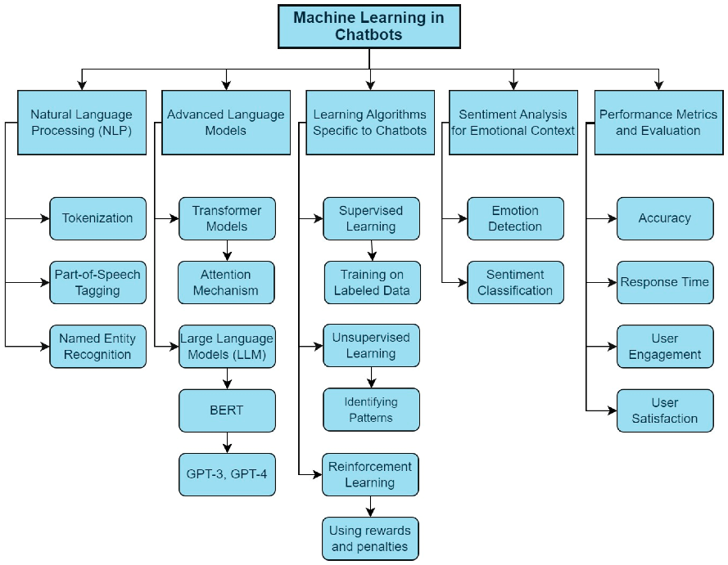

Figure 2 - Machine leaning concepts for chatbots – (Izadi and Forouzanfar, 2024)

To sum up the key concepts that have been discussed, chatbots have a variety of key integrations that allow them to flourish in the world of technology as noted in Figure 2, which provides a structural blueprint to build and enhance chatbot applications, ensuring they can effectively communicate and respond accurately. These integrated concepts within chatbots enable them to effectively interact with users in a human-like manner, responding to users 24/7 which improves the customer service level of businesses. As a result, chatbots have become a central tool that are used globally by various business sectors to enhance their operations in pursuit of greater success.

2.2 Common vulnerabilities within Chatbots

Despite the many benefits that AI chatbots provide for businesses and users globally, there is a growing concern regarding the rise of vulnerabilities within chatbot applications. Vulnerabilities are defined by a weakness within a system that can be exploited by attackers. There are numerous factors that amplify the level of vulnerabilities within a system which include weak coding, outdated hardware, and inadequate firewall protections. (Eltahir et al., 2022; Hasal et al., 2021). The stride model can be used to address the various security threats which include cyber-attacks such as spoofing, Denial of Service Attacks, and Elation of Privileges. (Zainabi, Maleh and Belaissaoui, 2024).
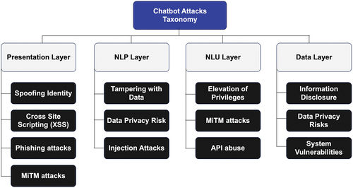
Figure 3.1 - Chatbot Taxonomy - (Zainabi, Maleh and Belaissaoui, 2024)

Figure 3.1 demonstrates a structured overview of potential cyber-attacks that chatbots could potentially face, allowing developers to identify and predict vulnerabilities within their system and apply defensive systems to nullify the attacks. Figure 3.1 clearly highlights how potential attacks are categorised across key layers of the chatbot’s system, allowing for a more effective defensive framework to mitigate potential vulnerabilities.
A potential vulnerability that chatbots regularly face is spoofing identity. This attack is where an attacker impersonates a user to gain unauthorised access to a system giving them the power to tamper with data and steal sensitive user information. There are various forms of spoofing attacks, including IP, and DNS spoofing, all with the sole purpose of deceiving the targeted system to gain entry. (Babu & Bhaskari, 2010). In regard to chatbots, attackers can develop chatbots that deceive users into clicking on insecure links and documents thus giving them access to users’ private information which can result in ransomware attacks.
A common vulnerability within chatbot applications is the tampering of data whereby an attacker gains access to data, modifies it, misleading users through unauthorized access. (Baudart et al, 2018). This can be achieved through an SQL injection attack whereby an attacker injects malicious “SQL queries into an application via the input data received from the client”. (Ye & Li, 2020). In doing so, the attacker has the power to manipulate databases by retrieving and deleting data, thus gaining access to important customer data or potential business information which could prove to be devastating for the business. A further risk to the security of chatbots is Man-in-the-Middle (MitM) attacks which involve a cybercriminal being between the sender and receiver of a message thus giving them the ability to steal data. Another way the same outcome can be achieved is through eavesdropping which involves an attacker listening to the communication between the user and chatbot hoping to find valuable information that can be of use such as login details, bank details etc. (Kampourakis et al, 2022).
Additionally, chatbot security can be exploited through a Denial-of-Service attack (DoS) which involves overwhelming a system with requests causing it to become inefficient and unresponsive, unable to execute users’ requests accurately as a chatbot. In November 2023 it was reported that ChatGPT was targeted by a cyber attacker through way of DDOS attack. It was reported that the OpenAI was hit with “abnormal traffic” causing their system to have a “degraded performance” unable to fulfil the requests of users causing them to become agitated and outraged. (Mauran, 2023). From this, we learn the significance of these various attacks highlighting the need for chatbot security to constantly be improved and updated. Similarly, the Elevation of Privilege (EoP) attack is focused on the attacker gaining access to the system through targeting the weaknesses of the system, handing them access to privileged information and higher-level functions within the system. (Zainabi, Maleh and Belaissaoui, 2024). Particularly within Finance, Business, and E-commerce, this attack could prove to be costly for these sectors as they handle highly important user information. Through this attack it allows the cybercriminal to gain full control of the system thus giving them the power to breach and steal sensitive data. This emphasises the importance for the sectors listed to focus on making their chatbot security bulletproof which would make them successful and avoid reputational damage.
Aside from multiple cyber-attacks proving to be a significant weakness for chatbot systems, it can be argued that a differing weakness would be the ability of chatbots to completely reciprocate human emotional intelligence. In order for chatbots to completely reciprocate human intelligence they would need to be instilled with the ability to understand, interpret, and respond appropriately to requests. Often within chatbot systems, it can be argued that the majority of responses to users are pre-written which creates a sense of emptiness to users as they believe chatbots can’t reflect empathy in conversations. As a result, users’ satisfaction will be reduced significantly, especially within the Finance sectors and E-commerce sectors, where emotional relationships between users/customers can be viewed as vital. Despite the improvement of Artificial Intelligence, achieving human-like emotion is a constant challenge that is not being addressed as it involves complex psychological involvements that go beyond the realm of AI capabilities.
Furthermore, a threat that always lurks for chatbot platforms is the need to comply with GDPR rules and regulations. This is significantly important for chatbot platforms as they handle large amounts of customer/user data that must be handled correctly and ethically. There are various rules within the GDPR for example article 5e orders that personal data shall be within systems for no longer than necessary. (Hasal et al., 2021). For chatbots, this means they must implement strict security to ensure there are no loopholes within their security posture. This means that chatbots must ensure the authentication of users, gather all forms of data of users, and match the details to their personal rights allowing for the monitoring of users’ actions. (Hasal et al., 2021). In 2023 EOS Matrix was fined £5.4 million euros for not taking appropriate technical measures to protect the personal data of users and clients. (Komnenic, 2022). This is one of many examples of businesses not complying with GDPR rules thus facing heavy fines and damage to their brand reputation. This clearly illustrates how imperative it is for businesses to oblige with GDPR rules as it limits their vulnerabilities within the system whilst ensuring they stay competitive.
Beyond complying with GDPR regulations, a threat that can overcome chatbots is the need to comply with various legislations such as user usability. According to (Lewis and Sauro, 2021) user usability can be defined as the extent “to which a product can be used by specified users to achieve specified goals with effectiveness, efficiency, and satisfaction in a specified context of use”. This is an important aspect to discuss as it obligates businesses to ensure they have an effective system that achieves its purpose thus fulfilling the needs of users and customers. Within the context of chatbots, developers must ensure that the user experience is enjoyable and efficient allowing for users’ queries to be answered and executed accurately. Furthermore, ISO/IEC 27001 (information security Management) is a recognised standard for security management to ensure data protection practices. The significance of complying with these various standards helps a business legally, and socially whilst ensuring they maintain their competitiveness in their market as well as their brand image.

Vulnerability/Threat | Description | Case Study | Deep Analysis
System Vulnerabilities | Weaknesses in the chatbot system that can be exploited by attackers to perform unauthorized actions | Microsoft Tay | The Tay chatbot incident demonstrates how quickly machine learning  Algorithms can be manipulated by malicious users, underscoring  The need for robust input filtering, ethical AI guidelines and continuous  Monitoring.
Spoofing Identity | Impersonating an authorized user to gain illegitimate access | Banking Chatbot Phishing Attack | The phishing attack on a banking chatbot highlights the critical  importance of strong authentication mechanisms,  including multi-factor authentication and biometric verification,  to protect against identity spoofing and phishing scams.
Tampering with Data | Unauthorized alteration, manipulation, or destruction of data | SQL Injection in E-commerce Chatbot | The SQL injection attack on an e-commerce chatbot underscores  the necessity of proper input validation, secure coding practices,  and the use of prepared statements to prevent data tampering  and unauthorized data access.
MitM Attacks | Intercepting and potentially modifying communications | MitM Attack on Home Assistants | The MitM attack on home assistants highlights the need for  secure communication channels and robust encryption methods,  such as end-to-end encryption, to prevent data interception,  eavesdropping, and unauthorized access.
DoS/DDoS Attacks | Overwhelming a system with excessive requests, causing it to slow down or become unresponsive | DDoS Attack on Customer Service Chatbot | The DDoS attack on a customer service chatbot illustrates the  importance of implementing rate limiting, load balancing,  and other network security measures to maintain system  availability, performance, and resilience against DoS and  DDoS attacks.
Information Disclosure | Unintentional exposure of sensitive information | Data Leak in ChatGPT | The data leak in ChatGPT due to an open-source library bug  highlights the necessity of robust privacy-preserving measures,  regular security audits and ensuring that third-party libraries  are secure and up to date to protect sensitive user data.
Data Privacy Risks | Insufficient security measures leading to unintentional disclosure of PII | Privacy Breach in Healthcare Chatbot | The privacy breach in a healthcare chatbot emphasizes  the critical need for stringent security measures, such as  end-to-end encryption, proper access controls,  data minimization, and anonymization techniques  to protect sensitive health information.
Elevation of Privilege | Exploiting vulnerabilities to gain unauthorized access to higher-level functions or data | EoP in Financial Chatbot | The EoP incident in a financial chatbot showcases the  importance of robust privilege management,  regular security assessments, prompt software patches,  and updates to prevent unauthorized access and exploitation  of vulnerabilities.
Figure 3.2 Summery Table of Vulnerabilities (Zainabi, Maleh and Belaissaoui, 2024)
Figure 3.2 provides a detailed summarised explanation of the key vulnerabilities within chatbot platforms. It provides a relevant event that corresponds to the attack, which further highlights the importance of developing secure solutions to mitigate these threats.
In summary, there is a significant concern regarding the rise in vulnerabilities within chatbots as they have become more popular. Some of the main concerns are regarding the chatbot systems’ inability to defend against cyber-attacks such as MiMA, DDOS, SQL injection, spoofing attacks, phishing attacks, and EoP attacks. As well as these numerous vulnerabilities, some further weaknesses of chatbots include their inability to have human-like emotion and intelligence which can prove to be costly for businesses. However, this dissertation aims to produce security-enhancing guidelines for developers with the sole aim of elevating their security posture, resulting in their chatbot systems being difficult to bypass for attackers.
Furthermore, whilst discussing chatbots it is important to recognise and discuss the social, legal, and ethical issues that chatbots face in the digital world. This section, alongside a deeper analysis of the compliance of legislations for chatbot platforms will be discussed in in the second part of this dissertation.

2.3 Legislation of Chatbots

The importance of complying with a set of rules and regulations must not be overlooked by businesses globally. To begin with, businesses must ensure they operate ethically, protecting the rights of their clients and customers. Specifically, within the sectors that handle huge volumes of client data, businesses must ensure that they implement appropriate strategies to manage and safeguard sensitive information effectively. The consequences of businesses being complacent in regard to the compliance of legislations and regulations include financial loss, reputational damage, and potential criminal incrimination. As clearly highlighted, the importance of businesses complying with rules and regulations must not be neglected and must be a core objective for businesses globally to acknowledge.
In an attempt to further boost the overall security level of chatbot platforms, it would be beneficial for all developers to perform security reviews of their platforms. This would consider any potential vulnerabilities within the system which can be avoided through the implementation of relevant solutions. As well as this, it allows for an understanding of the business’s compliance regarding the General Data Protection Regulation (GDPR) and allows for an in-depth assessment of customer service, allowing the business to implement relevant techniques to improve customer service if needed. According to (Hasal et al., 2021) article 32a of the GDPR specifically requires that companies take action to encrypt data, highlighting how essential it is for chatbot developers to take the security of chatbots seriously, which automatically ensures compliance with GDPR regulations thus avoiding financial loss and reputational damage. To summarise, in order for chatbots to continue to be successful and an effective tool globally, it is imperative that the group of chatbot developers implement the security techniques that have been discussed. It is an obligation for the personal data of users to be handled safely with security techniques implemented in order for their data to stay secure, thus complying with GDPR. By prioritizing the security of chatbot platforms it guarantees the growth of AI chatbots within the world of technology.

2.4 Chatbot Platforms

There are various online chatbot platforms that businesses use in order to design and develop effective chatbot platforms. These platforms include Tidio, Rasa, and IBM Assistant, which are widely used by users and business sectors today. Before analysing the features, benefits, and architecture of these platforms it is necessary to discuss the types of chatbots that are available.
Chatbots primarily can be categorised into 2 types: Rule-Based chatbots which operate on a set of rules and pre-written responses. They are centred around handling users’ queries based on a set of conditions and are able to handle small queries through pre-programmed answers. (Izadi and Forouzanfar, 2024). An example of a rule-based chatbot is APU Admin Bot which is designed to handle student queries and respond based on questionnaires and interviews. This chatbot successfully provides users with relevant information and effectively answers their queries. (Izadi and Forouzanfar, 2024).
The most commonly used chatbot application is AI-based chatbots which are integrated with Machine Learning techniques, NLP, and LLM which enhance the ability of chatbots to provide human-like communication. The implementation of AI based chatbots is commonly used in customer service sectors such as E-commerce, Finance, and Business as chatbots enhance their customer service by providing 24/7 responses accurately and customised feedback to users. The structure of chatbots can be understood from Figure 4 which portrays a client server design, displaying how human input and communication is achieved. This thesis will develop on the various features and architecture of chatbot platforms analysing their structure whilst also pointing out their vulnerabilities.
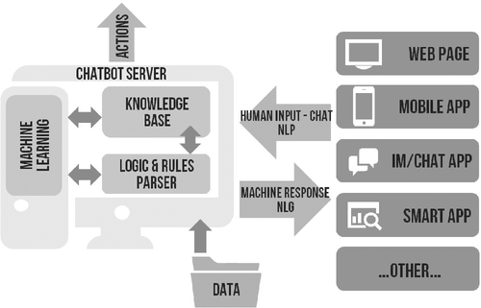

Figure 4 - The Structure of Chatbots - (Hasal et al., 2021)

2.4.1 Rasa Platform

Rasa is a powerful open-source tool that is used by healthcare, Banking, Financial, and E-commerce sectors to create AI chatbots in the hope of enhancing their business operations. The platform is composed of two main components: Rasa NLU, which handles the interaction with users, and Rasa core which is focused on the execution of queries and responding with context. Rasa is a widely preferred platform due to its ability to deliver a customised user experience, enabling developers to alter their chatbots to fit the purpose of their business statement. As well as this, Rasa is integrated with various machine learning concepts and NLP techniques which are moulded together, creating an adaptable, intelligent human like chatbot.
The fundamental aspect of Rasa capabilities is its integration of NLP within its system. The use of NLP frameworks enables Rasa to effectively understand, analyse and respond to users’ queries resulting in human-like interaction. Furthermore, Rasa provides businesses / developers with the option to train their chatbots to analyse user input and behaviours which enables them to provide relevant and personalised interaction. (BotPenguin, 2024).
One feature of Rasa that makes it widely used globally is the use of policies. This concept is centred around the order of execution of user requests when conversing with users. Rasa executes users’ requests based on priority which allows for urgent requests to be handled immediately, avoiding potential problems for the business in the near future. (Kumar Sharma and Joshi, 2020). Furthermore, one of the biggest strengths of Rasa platform is its ability to manage high volumes of complex queries. The application is engrained with the ability to handle multiple conversations, remembering previous user requests whilst ensuring there is not decrease in the efficiency of executing users’ queries. Rasa core allows developers to engage with users in contextualised scenarios whilst fulfilling the needs of users which results in an increase in customer experience and satisfaction. (BotPenguin, 2024).
In addition, another strength of Rasa that proves to benefit users and businesses is its ability to integrate with external devices and APIs. This means that Rasa has the ability to access valuable information externally and execute commands in order to provide excellent services to users. The use of API’S enhances chatbots’ abilities to communicate with databases, gaining access to valuable sources of information that allow them to perform actions on behalf of users. This enhances the customer service of the business as it provides personalised recommendations to users and solves complex queries of users accurately. In this way, Rasa ensures the chatbot stays efficient, relevant and adaptable in the world of Artificial Intelligence.
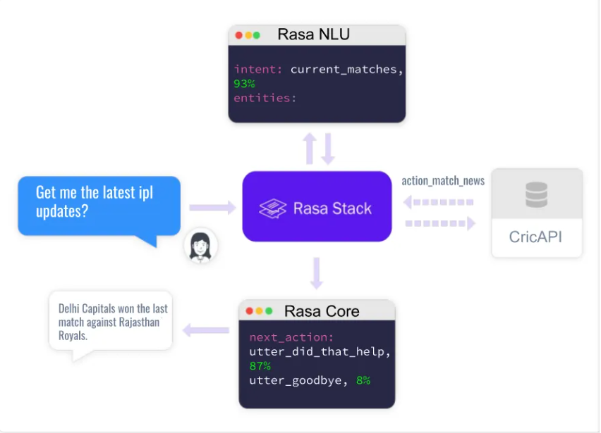
Figure 5.1 displays the structure of Rasa and the steps that are undertaken in order to process and execute users’ requests. The diagram highlights how the interpreter extracts any details and analyses the requests of users using NLP techniques. Then the tracker monitors the conversation and provides context. The purpose of the policy is to decide the best response to executing the command of users based on the order of execution. Once the policy is decided, the chatbot executes the command and displays it to the user. With these steps, it allows the chatbot to deliver coherent, accurate responses to users’ queries. For this reason, within the implementation section of this project a Rasa chatbot was selected due to its effective features that made it ideal for conducting effective OWASP Top 10 tests.

Figure 5.1- Structure of Rasa Platform

2.4.2 Botpress Platform
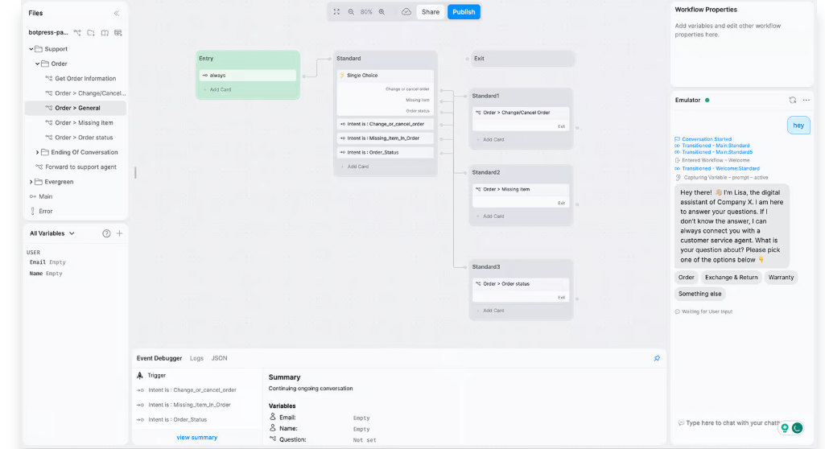
Similarly, to Rasa, Botpress is a chatbot building platform used by developers and businesses to create and monitor conversational agents with human like capabilities. This open-source platform allows developers to create chatbots that are tailored towards meeting the needs and wants of users. When using this platform, it provides developers with a Flow Builder which is a design mechanism allowing developers to visualize the process of conversing with users. This allows developers to plan and improve the implementation process of creating effective chatbots.
Figure 5.2 - The flow builder Botpress uses
As shown in figure 5.2, the Flow Builder implemented by Botpress is composed of nodes which represent a state, and transitions which are the connections between the nodes. (Wouters, 2024). Through the flow builder, developers have the ability to set specific conditions that must be met e.g. authentication of users whilst allowing them to set automated responses when certain criteria are achieved. This tool is beneficial for many developers and businesses as it provides a visual map of the chatbot and how each component is composed. Furthermore, the tool is practical and organised allowing for the development of highly intelligent and successful chatbots. (Wouters, 2024)
Some useful features that Botpress provides include the monitoring of user’s conversations which allows the chatbot to analyse its responses to users’ queries, thus allowing them to create a customised experience for users which boosts customer satisfaction. One of Botpress platform’s most distinct functionality is the use of AI and multiple agents which all serve specific purposes. (Wouters, 2024). As an example, Botpress has created a knowledge Agent which answers questions about topics once uploaded. Another example that can be noted is the use of personality agents which mould responses to match the personality that is chosen by users. This innovative approach allows users / businesses to enhance their user experience, allowing them to provide a high level of service, making them a powerful tool for various sectors globally. (Wouters, 2024).
Like the majority of chatbot platforms, Botpress provides built in NLP techniques that enable chatbots to analyse and comprehend user queries in order to provide an accurate response. Through the use of NLP, Botpress chatbots can handle large amounts of queries simultaneously which ensures there are no delays in executing user queries. To reinforce the effectiveness of Botpress as an open-source platform, it allows businesses to upload their chatbots across various apps such as WhatsApp, Facebook, Snapchat, and Slack. This serves as an opportunity for businesses to expand their accessibility across various communication channels, allowing customers to engage with the chatbot in an environment suited to them which increases customer satisfaction. (Wouters, 2024). As well as this, it creates a reputable brand image for the business, facilitating them to expand in their respective business market.
To help improve user conversation, Botpress integrates analytic tools to monitor users’ conversations, chatbot performance, and conversational flow. From this, businesses and users can produce performance review documents highlighting techniques and procedures that can be implemented to improve the functionality of the chatbot whilst ensuring conversation with users mirrors human like interaction. Botpress ensures that the authentication of users is a core part of their platform security as they have multiple ways users can authenticate their identity. For instance, users can authenticate using a token or can be authenticated using an external party. This is a security procedure that must be secure and protected to ensure all users data is well handled whilst fortifying the security of the system in case of a potential cyber-attack in the future.
To sum up, Botpress is a widely used chatbot platform that various sectors use to build bots and conversational agents in the hope of improving their customer experience. Through the use of key features that have been thoroughly discussed, it permits developers / businesses to produce intelligent, diverse, and adaptable chatbots that facilitate in creating a systematic, efficient service to users.

2.5 System Architecture of Chatbots

The architecture of chatbot platforms provides developers and users with accurate and engaging interactions with users. It designs the construction of the user interface, inputs from users, and the response from the chatbot. In order to gain a thorough understanding of the architecture of chatbots, it’s important to discuss what chatbot architecture refers to. The architecture of chatbots refers to the structural techniques that are implemented within the system, it contains the various algorithms, NLP, and machine learning concepts that form the core of the system operations.
A key aspect of the architecture of chatbots is the composition of the user interface. This is a segment of the architecture that must be composed critically as it is the primary point of interaction between the chatbot and users / businesses. (Adamopoulou and Moussiades, 2020). The design of the user interface must be compiled in order to influence user engagement and satisfaction ensuring their needs and queries are met. Through the input of the user, the chatbot has the ability to understand users’ needs and implement relevant strategies to execute their requests. (Adamopoulou and Moussiades, 2020). Generally, the chatbots platforms interface is composed of input fields where users can type and search for requests, thereafter the user will have access to the response area where the response of the chatbot will appear. In order to ensure businesses and users are satisfied, the user interface must aim to be interactive, and accessible creating a user-friendly experience.
Another aspect of chatbot architecture that is seen as essential to their overall design is the feature of dialogue management. The Dialogue management aims to control and manage the conversation between users and the chatbot whilst ensuring conversations are contextualised. (Kucherbaev et al., 2018). The Dialogue management component is composed of handling techniques. This aspect revolves around the implementation of ambiguity handling which provides answers to users’ requests regardless of whether the needs of users are unclear. Furthermore, the Dialogue management includes data handling which ensures the correct handling of data allowing to tailor user experience to the needs of users. (Adamopoulou and Moussiades, 2020). Additionally, the Dialogue Management component is responsible for keeping track of the state of the conversation, the state of the conversation can then be labelled as grounded (users’ input is acknowledged), slot filling (the request of extra information from users), and context switch (change of direction when conversing). (Huang, 2021). Generally, chatbots develop algorithms that use dialogue strategies through receiving feedback from users and analysing their behaviour to provide customised experiences for users.
Another segment of architecture that forms the structure of chatbots is the use of backend systems. Through the use of external APIs, it inhibits the chatbot from understanding the intent of users fulfilling them accordingly. An example of an external tool that is used by the chatbot is Relational Databases as it produces user information and data from past conversations that can be analysed and used to enhance customer experience. (A & John, 2015). From the use of backend systems users’ interaction can be logged and monitored allowing valuable insights into the performance of the chatbot and the engagement of users. This feedback is essential for businesses specifically as it allows them to improve the accuracy of chatbot and conversational abilities.
Machine Learning approaches are the central piece of chatbots as they allow them to flourish with their functionalities. One of the most essential machine learning approaches is the use of Natural Language Processing, which enables computers to interpret and generate meaningful responses to users which has been discussed in this thesis previously. Alongside this the use of Natural Language Understanding (NLU) allows chatbots to gain contextual knowledge from user’s intent and respond based on their needs. (Jung, 2019). Through these layers of machine learning techniques embedded within the systems of chatbots, it grants chatbots the ability to acknowledge user intents and identify key instructions from user input whilst monitoring the context of the conversation, which consequently allows for a tailored response for users.
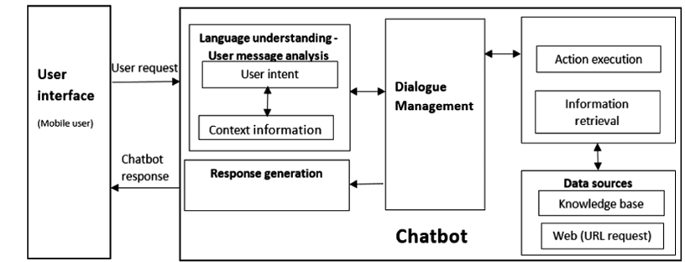
Figure 6 - General Architecture of Chatbots (Huang, 2021)
Figure 6 provides an overview of the steps taken in order to respond to users accurately. The dialogue begins with understanding user intent to the management of dialogue, analysing and executing commands of users. Through each of these steps, it allows for an efficient successful experience for users and businesses as it places the needs of users at the forefront of their operations. To summarise, this figure helps to visualise the multiple sections that must be developed in order for chatbots to be viewed as adaptable and capable of handling the distinct needs of users.

2.6 Social, Legal, Ethical Issues (LSEPI)

While there are many benefits to the use of chatbot platforms, it is imperative to discuss the social and ethical issues of chatbots, expressing how they need to be addressed. A social aspect that is regarded as the biggest problem is maintaining transparency with users and ensuring users are not deceived. Transparency allows users to trust chatbots increasing their interaction and engagement which improves customer experience and satisfaction. Furthermore, through providing constant transparency to users it guarantees businesses and chatbots to be compliant with GDPR and various other regulations. Additionally, it can be argued that chatbots have fragments of bias within their system when responding to or conversing with users. (Pentina, Hancock and Xie, 2022). This can be apparent in the implementation of algorithms as bias can be introduced when users’ intents are ranked which can alter how users’ intents are understood and executed. Likewise, many chatbots specifically ones that are rule based are predetermined in regard to responding to users which causes significant issues when unexpected, complex queries from users are requested. (Pentina, Hancock and Xie, 2022). The aspect of bias within chatbots could prove costly for businesses and developers as there is a significant decrease in effectiveness and user satisfaction, thus affecting the operations of the business particularly if the chatbot is a central point in business operations.
A further key social aspect that is apparent within chatbot applications is ensuring chatbots remain socially responsible when dealing with sensitive user requests. Many users may revert to chatbots to inquire about sensitive issues such as mental health and personal issues as they don’t feel comfortable talking to humans. In this instance, it is imperative for chatbots to be integrated with the appropriate techniques, so that they can handle and respond to such topics successfully by directing users to seek medical assistance. In this way, users gain a higher level of trust for the chatbot, consequently, increasing customer experience.
As the popularity of chatbots increases rapidly globally, there is a reflective rise in ethical issues within chatbot platforms. A main area of ethical concern for developers and businesses is maintaining privacy and data security for users. The collection of data which includes sensitive user information and their most frequently asked queries, must be handled in an ethical manner that guarantees its safety from potential cyber criminals and vulnerabilities within the system. Within the field of AI and chatbots user privacy and security are paramount as AI systems are being used by various sectors to make “substantial decisions”. (Ruane, Birhane and Ventresque, 2019). Ensuring user privacy and security is becoming increasingly difficult and it can be argued that this is gradually becoming a global concern as there is no fixed algorithm to assure users that their data is safe and secure. Despite this, there are many various approaches developers and businesses can take to mitigate these threats which include data encryption and user authentication techniques. Additionally, it is an ethical obligation for developers and businesses to ensure users choose how their data is handled, and how they prefer to interact with the chatbot ensuring users are at the centre of operations. (Ruane, Birhane and Ventresque, 2019). Maintaining transparency with users in regard to why and how data is being collected for instance is ethically correct as it reassures users and customers that their personal information is being handled correctly thus increasing customer satisfaction and experience.
Another example of an ethical consideration that chatbot platforms must aim to avoid is algorithmic bias. This is centred around machine learning algorithms carrying inherent bias on large amounts of data, leading to inaccurate and even unfair assumptions and responses. As chatbots tend to contextualise and reflect on past interactions there may be cases of imbalances within the data which algorithms may process to formulate their responses. As a result, this leads to inconsistent user experience as certain users may receive less quality responses as well as causing users to lose trust in the chatbot and its ability to replace human interaction. It can be argued that in the past years, users are relying heavily on chatbots in all aspects of life, perhaps even with mental health support. For sensitive topics such as mental health issues, chatbots must have pre-determined responses to urge users to seek professional help and not provide responses that can potentially cause more harm and confusion to users. In this respect, it is imperative for developers and businesses to address all ethical issues within chatbots, implementing necessary procedures to maintain user privacy and a successful functioning chatbot without loopholes.
When discussing legal considerations within chatbot platforms one of the most critical considerations is ensuring compliance with GDPR and various other data protection laws, ensuring businesses are responsible for the handling of user data, and mitigating the potential threat of cyber-attacks. Furthermore, if organizations are found guilty of misusing the personal data of users and exploiting them, they would face financial repercussions as well as a drastic fall in their brand image. Some laws command organizations to explain to users how their data is being handled whilst allowing them to alter and delete unnecessary data. In this way, users are kept well informed regarding the handling of their data creating transparency between chatbots and users. In every phase of the development of chatbot platforms, developers and organizations must be wary of the legal backlash that will follow in case of data violations or the misuse of user data, highlighting the importance of creating a chatbot that complies with legal standards protecting both the organization and developers from legal implications.

2.7 OWSAP

OWASP (Open Web Application Security Project) is a nonprofit organization that was established in 2001 and provides a security blueprint for online web applications, mitigating the potential of malicious attacks. (B. Kiruba et al., 2022). OWASP can be used as a tool to acknowledge the top 10 vulnerabilities for websites, since 2003, which updates each year.
OWASP conducts security assessments based on a predefined list of specifications. (Harrisonet al 2016; Sonmez, 2019). This is beneficial for businesses as it allows for a security assessment to be implemented resulting in gaining valuable information into the systems weaknesses and potential vulnerabilities, thus improving the overall security posture of the organization’s system. (Wen and Katt, 2023). OWASP top 10 is a widely acknowledged resource used by numerous organizations globally as it produces an updated list of the top ten security risks to applications which include SQL injection attacks, Injection, sensitive data disclosure, and security misconfiguration. From this organizations can implement testing techniques in order to check for these various threats resulting in creating a bulletproof secure system. This open-source application can be used by security analysts, pen testers, developers, and enthusiasts. This tool grants them the ability to deal with vulnerabilities, identify bugs within systems, and understand common security faults within website applications. (B. Kiruba et al., 2022).
In regard to this project, OWASP can be used as a tool to test open source chatbot platforms against the most common vulnerabilities to their system. From this organizations can derive results and conclusions that evaluate their system’s ability to repel these vulnerabilities. Additionally, if the organization finds that its chatbot platform is prone to the listed vulnerabilities on OWASP, it can develop secure solutions to counter the vulnerabilities, ensuring its system remains secure and difficult to penetrate. This methodology will be adopted within the implementation phase of this project, thereafter, drawing security guidelines and conclusions to benefit organizations and developers.
This dissertation will mainly focus on four of the OWASP’s top 10 vulnerabilities. One of the most relevant and complex tests to apply to the chatbot platform is the injection tests. This includes analysing users’ inputs, thereafter, inputting malicious queries to evaluate the chatbot’s ability to handle injection attacks. This is one of the most important vulnerabilities to test due to its complexity, as there are many entry points within chatbot platforms to inject malicious queries.
Another important vulnerability from OWASP top 10 that will be tested for within the implementation phase of this project is Broken Access Control. This is an important test to acknowledge as it is based on attackers aiming to bypass authentication techniques. For chatbot platforms, this is essential to test for as a vulnerability as many platforms have authentication mechanisms once users have logged in. This vulnerability is a high vulnerability according to OWASP’s top 10, making it essential to test my chatbot platform for this vulnerability, and thereafter, detailing its response.
The final test that this dissertation will perform on my chatbot platform will be the vulnerability of security misconfiguration which is a significantly prominent vulnerability according to OWASP’s top 10. This test is essential to carry out as there may be open pathways within the chatbot system that attackers can bypass. Additionally, this test allows to check for any misconfiguration in regard to the API keys used and databases. A complex test that I hope to complete once these 3 tests are recorded is the test for cryptographic failures which is a more complex vulnerability and will require an in-depth analysis of the encryption mechanisms, API protection, and security tokens, which ensure users’ data is secure and protected. Producing these main tests, will allow me to understand my chatbot’s capabilities and how it responds to the most prominent web vulnerabilities. Thereafter, guidelines and security recommendations can be introduced to aid developers and organizations in the best techniques that can be implemented to elevate their chatbot security.
Another tool and concept that can be used as guidance to ensure the tests are completed effectively and accurately is the STRIDE model. This is a threat modelling framework that categorises potential security threats in applications across six core areas which include Spoofing, Tampering, Repudiation, Information Disclosure, Denial of Service, and Elevation of Privilege. This concept allows developers to identify vulnerabilities similar to the OWASP top 10, allowing mitigation procedures to be implemented to halt these vulnerabilities. By acknowledging the STRIDE model, it ensures organization’s chatbots are secure, resilient, and bulletproof against complex cyber-attacks.

OWASP Top 10 Selection
Test Number | OWASP Rank | Test Category | Selected Test | Justification
1 | 1 | Broken Access Control |  | Important as it ensures all users are authorized and cannot perform privilaged actions.
2 | 2 | Cryptographic Failures | *Complex & Challenging* | Involves complex tests on password hashing and API’s.
3 | 3 | Injection |  | One of the most common types of vulnerabilities, due to the malicious payloads that are entered into the chatbot.
4 | 4 | Insecure Design |  | This test focuses more on architectural flaws rather than the security flaws.
5 | 5 | Security Misconfiguration |  | Ensures there are no loopholes within the system, and highlights the weaknesses within the system.
6 | 6 | Outdated Components |  | Not tested as the chatbot was developed on PyCharm with the most up to date version.
7 | 7 | Authentication Failures |  | Tests will be done to focus on the authentication but will not focus on multi-factor authentication methods.
8 | 8 | Software and Data Integrity Failures |  | Not tested as the chatbot does not handle data integrity requirements.
9 | 9 | Security Monitoring Failures |  | Was seen as insignificant compared to the other selected tests, however could be done in the future.
10 | 10 | Server-side requests |  | Not a relevant test as there is no server – side requests made on the chatbot.

This table details the selected tests that will be carried out within the implantation phase. The most relevant and complex vulnerabilities have been identified according to their influence on chatbot platforms.

3 Requirements & Analysis

This section will list the functional and Non-functional requirements of this project. It will also include diagrams to help illustrate the design of this project before it is implemented.

3.1 Functional & Non-Functional Requirements

Requirements are divided into two categories: functional and non-functional requirements. Functional requirements refer to the design and functionalities of the product whilst non-functional requirements refer to the operations and performance of the system. Table 1 below lists the functional requirements.
Table 1 Functional Requirements
Number | Requirement
1 | Create a Rasa chatbot using PyCharm for a Hotel business.
2 | Implement a simple conversational flow with personalised responses to hotel users’ queries.
3 | Conduct the selected tests from OWASP Top 10 on the Rasa Chatbot and evaluate the response of the chatbot.
4 | Document the methodology and process of implementing the various tests.
5 | Reflect on the chatbot’s security weaknesses revealed during each test.
6 | Produce security recommendations and guidelines for improving the security of chatbot platforms.

Table 2 Non-Functional Requirements
Number | Requirement
1 | Each penetration test should be completed within a reasonable timeframe.
2 | Ensure all testing techniques comply with GDPR rules and regulations.
3 | Ensure the chatbot system adheres to OWASP Top 10 guidelines.
4 | Ensure the chatbot system adheres to ISO standards.
5 | Ensure the chatbot maintains accurate results throughout all tests.

3.2 Associated Diagrams

Diagrams typically visualise the design, process, and architecture of a project. Unified Modelling Language (UML) helps to visualize these concepts. UML diagrams are normally composed of actors which is represented by a stick figure, who interact with the system. The two main actors of this project will be the chatbot platform and the tester. The tester will test and interact with the chatbot platform, by firstly creating a dummy chatbot and thereafter implementing authentication techniques, allowing the tester to perform relevant testing techniques.
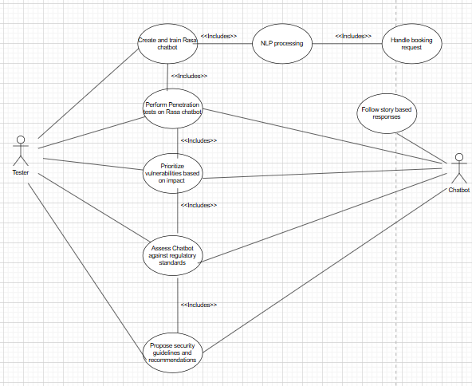
Use Case Diagram of Rasa Chatbot
Figure 7.1 - Use Case Diagram
Figure 7.1 displays the actors of this project as well as the use cases representing the various actions and tasks that must be completed in order to complete this project successfully. The diagram shows how each use case is interconnected, emphasizing the interconnected relationship between various components of this project.
Use Case Diagram from Attackers perspective
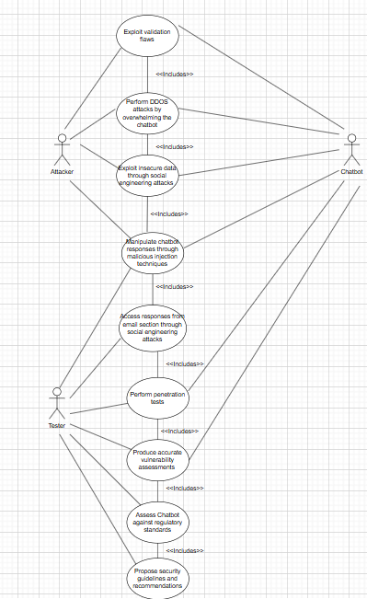
Figure 7.2 – Alternative Use Case Diagram

Figure 7.2 displays an alternative use case diagram, demsonstating the various methods an attacker can use to exploit the chatbot system. The attacker is clearly connected to other actors, emphasing the effect and influence the attacker has on various components of the chatbot system.
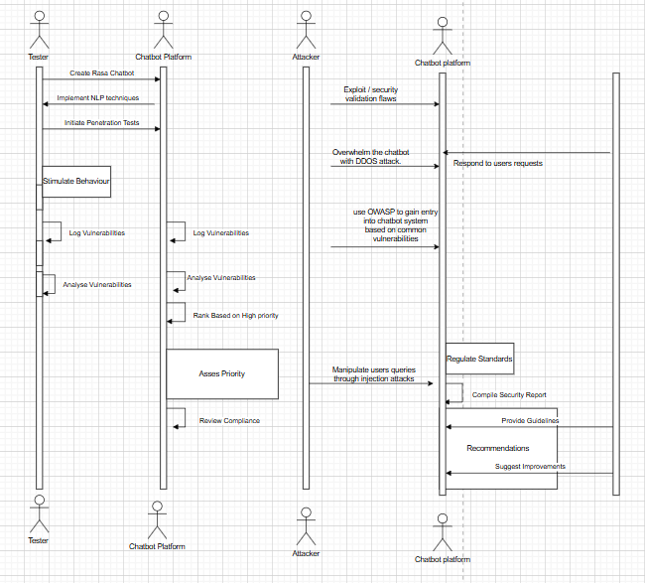
Sequence Diagram of Chatbot
Figure 8 - Sequence Diagram

Figure 8 demonstrates a sequence diagram illustrating the same processes and steps as the figure 7.2. However, it provides an alternative way of visualizing the architecture of this project. The figure displays various actors highlighting their various roles and responsibilities, as well as visualizing how each actor is connected to one another.

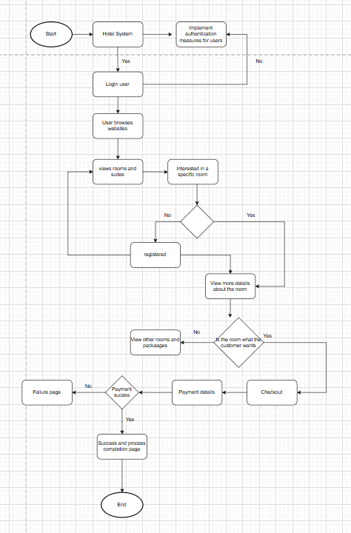
Activity Diagram of Hotel System
Figure 9 - Activity Diagram

Figure 9 visualises an activity diagram of a hotel website, displaying the structure and the process of composing an effective hotel system. This is useful to understand and visualize as my Rasa chatbot will be tailored towards a hotel booking system, highlighting the importance of this visual diagram.
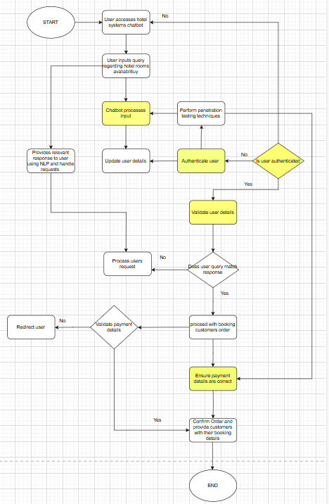
Activity Diagram of Chatbot Integrated on Hotel Booking System
Figure 10 - Activity Diagram of Chatbot in Hotel System Context

Figure 10 is similar to Figure 9; however, Figure 10 displays the integration of a chatbot system in a hotel booking system context, visualising its functionalities and responsibilities in ensuring the hotel system operates optimally. Figure 10 also highlights the access points of the system in yellow, representing opportunities where penetration testing techniques can be applied, and where attackers may exploit.

4 Design and Implementation

4.1 Implementation of Rasa Chatbot

Before the selected tests can be applied, it is necessary to create a suitable, contextualised environment, which will allow for the tests to be completed efficiently, providing accurate results. In order to do this, the application PyCharm was used to create a functioning chatbot for a hotel booking system. PyCharm was selected due to its integration with Rasa, allowing users to access the Rasa platform’s functionalities through its system.
To begin with, to install and access Rasa through PyCharm there were many commands that had to be executed within the terminal of PyCharm. As shown in figure 11.1, relevant commands must be executed in order to access Rasa platform functionalities and create a project.
Number | Command | Purpose
1) | 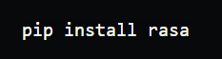 | Installs rasa and its dependencies.
2) | 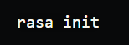 | Creates a new Rasa project
3) |  | Trains the chatbot using the NLU and stories.
4) |  | Starts an interative session in the terminal to test the chatbbots functionalities.
Figure 11.1 - Rasa Installation commands

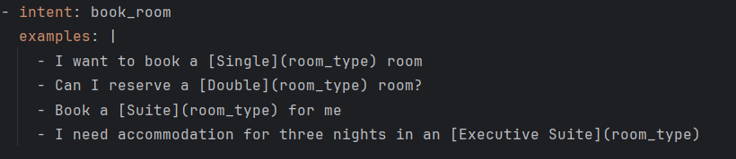
Once Rasa has been installed and a project has been created, PyCharm allows for specifc chatbots to be created for specific contexts. One of the main files that the chatbot relies on is the NLU.yml file which defines the chatbot’s intents and examples of conversational starters from users. Intents are used throughout the file and their purpose is to categorise user inputs and provide a relavant response. This can be seen through the example below which creates an intent that handles the request of users booking a hotel room. The chatbot recognises the intent and provides an example response as shown in the figure below. Many intents can be created to mould the chatbot to handle specific user requests. Within this project, it is essential to create many different intents to ensure all potential user requests are handled successfully, before the selected tests are implemented.
Figure 11.2 - NLU File Intent Example

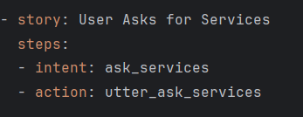
Another component that must be acknowledged and completed in order to create an effective conversational chatbot is the stories.yml file which effectively manages the dialogue between the user and chatbot. Stories are predefined sequences of user inputs and chatbot responses, therafter, steps are used which define the interaction between the user and the chatbot. As shown from Figure 11.3, the purpose of the story is to ensure a logical conversational flow after the user initiates an intent. The chatbot then responds by executing the customised action and populating the relevant response. This is another significnent aspect of creating a functioing Rasa chatbot as it ensures the conversation is natural and logical, mirroring the dialogue of humans.
Figure 11.3 - Stories file example

Furthermore, another step that must be created in order to create a human-like chatbot is the handling of rules. Within the rules.yml file, it allows for the defining of rules that correspond to specific intents. The main difference with stories is that the chatbot always responds on the same manner when users ask about a specific intent e.g. breakfast as shown in Figure 11.4. This allows the chatbot to provide consistent responses to intents which is an important aspect that must be implemented.

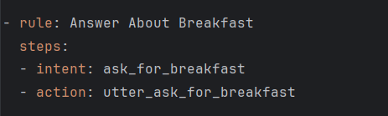
Figure 11.4 - Rasa Chatbot Rule example
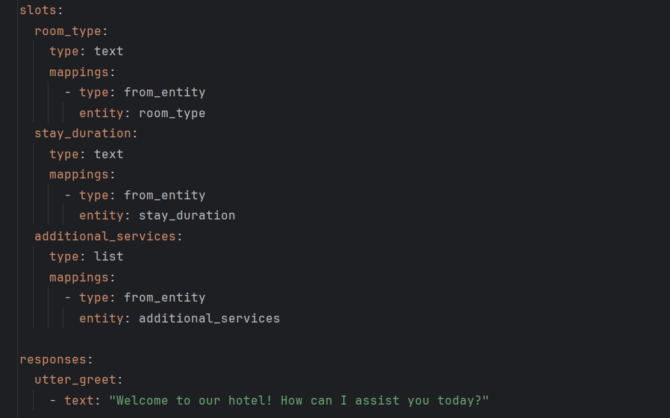
The file domain.yml is responsible for defining the responses, intents, and slots of the chatbot. The key components of this file are the intents which declare user’s inputs, the response which is prewriiten, corresponding to specific intents, actions that require Python execution, and slots which is data stored for later use. This particular file is an integral part of composing a Rasa Chatbot as it defines the chatbot’s memory to remember user input, creating a dynamic conversation based on user data. As shown in the figure below, the domain file has various key components which allow the chatbot to interact with users, forming the blueprint of the functionality of the chatbot. This file arguably is the most important file as it connects the NLP with the stories and actions, allowing for a successful, effective chatbot.
Figure 11.5 - Example of Domain
The final building piece to form a completely functioning chatbot lies within the actions.py which contains Pythin logic for cutomising chatbot actions. It allows for dynamic messaging between users and chatbots, generating tailored responses based on data that has been stored previously. As shown in Figure 11.6 the Python code generates dynamic responses and provides tailored responses to specific user intents, making the chatbot more realistic and user-friendly. Furthermore, this file is responsible for authenticating users by verifying their usernames and passwords thereafter assigning user roles after successful login. This file is also responsible for allowing users to book a hotel room, stores their details, and also allows users to cancel their selected bookings. This highlights the importance of this file as it plays a significant role in guaranteeing the security of the chatbot system.

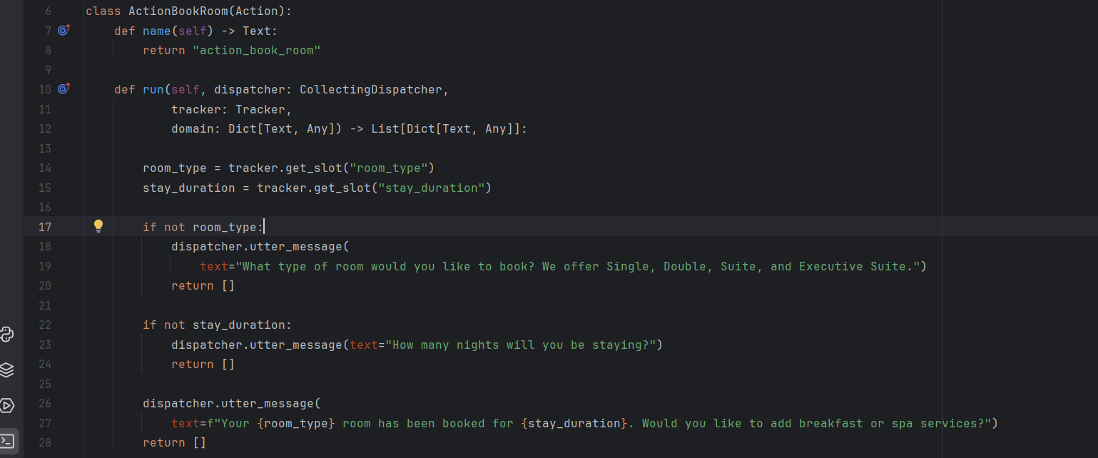
Figure 11.6 - Actions file
After completing and adapting all the above-mentioned files it allows for a functioning Rasa chatbot to be built, specific for a particular context (hotel booking). As shown in the figure below, a successful conversation between the Rasa chatbot and the user takes place. The conversation follows a structured, logical flow demonstrating the chatbot’s ability to understand user inputs, apply context, and respond appropriately. A controlled environment must be achieved before the selected OWASP tests are implemented to provide more accurate and realistic results.
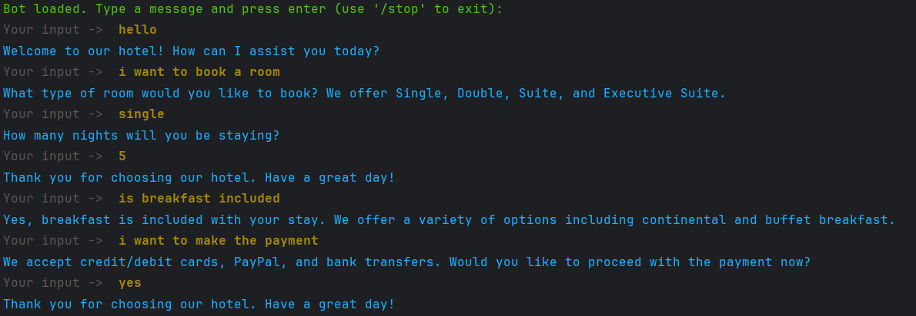
Figure 11.7 - Chatbot conversation

4.2 Test 1 – OWASP Injection Test
The Importance of Injection Testing
SQL Injection is a widely common web security vulnerability that allows attackers to manipulate a system’s database by injecting malicious SQL queries which consequently leads to unauthorized access, valuable data being intercepted and exploited. In the case that an attacker is successful in their SQL injection attack, they are then able to manipulate, delete data and bypass authentication. The OWASP Top 10 ranks Injection attacks as one of the most common and dangerous types of vulnerabilities, therefore, it is essential to implement this test on the Rasa chatbot platform, which will produce valuable information highlighting how prone the chatbot is to Injection attacks.
The goal of this test is to determine whether the chatbot is vulnerable to SQL Injection by attempting to inject malicious SQL payloads into the Rasa chatbot and evaluating its performance. Below is a block diagram that represents the aim and process of this test highlighting what specific system vulnerability will be tested and what the expected outcome of the test is.

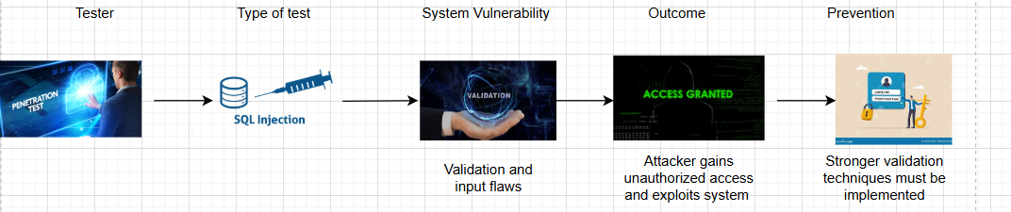
Figure 12.1 - SQL Injection Block Diagram in the user input field

Testing Environment
In order to do this test, I used PyCharm to develop my Rasa chatbot and installed the dependencies as mentioned in the section above. Furthermore, I created the chatbot for a hotel system which makes it context relevant allowing the results of the tests to be accurate and reliable.
Methodology

Examples of SQL injection attacks on the chatbot
The most effective method to measure how prone and vulnerable a system is to Injection attacks is to input malicious payloads into the input fields of the system, thereafter, evaluate its behaviour and responses. The same method will be implemented with this test.
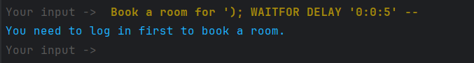
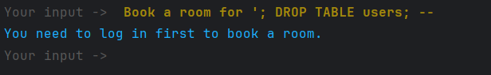
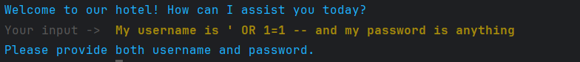
Injection attack using chatbot’s localhost however chatbot recognises the attack attempt and asks for user authentication
SQL injection that monitors if there is a delay with the chatbot response which would therefore make it vulnerable to injection attack
Figure 12.2 - SQL Test Results in the input phase
Chatbot not vulnerable to SQL attempt and asks for authentication.
Malicious SQL injection inserted
Chatbot Automated response

Analysing the chatbots Response
The purpose of the SQL injection test was to determine whether the chatbot system is vulnerable in any way to malicious injection inputs. The tests inputted payloads with the aim of manipulating the chatbot systems database, bypassing authentication, and blinding SQL injection. From the responses of the chatbot, it can be concluded that the chatbot is not vulnerable to SQL Injection attacks as it consistently rejects the attempt of the malicious payloads in bypassing its system.
The first image aimed to bypass authentication by injecting the SQL payload ‘OR 1=1 -, a commonly used injection payload that ensures the user is authenticated. The response of the chatbot was immediate, and it denied the request and asked for the user’s details highlighting how the chatbot is not prone to payloads aiming to bypass authentication.
The second image aimed to retrieve user’s details with the command UNION SELECT username FROM users --. In the event that the chatbot was vulnerable to this attack, it would return a list of all the users with their corresponding usernames. This would be catastrophic for the organization or individual who is responsible for the chatbot as it could lead to the breaches of data and valuable personal details being intercepted and exploited. Nevertherless, the chatbot successfully recognised the malicious payload and responded with the message “please provide both username and password”, highlighting how the chatbot is knowledegable and skilled at recognizing potential attacks and in response does not expose any sensitive information.
The aim of the third test as shown from in the figure above was to manipulate the database by executing the command DROP TABLE users;. The goal of this test was to evaluate whether an attacker is able to alter and delete valuable data from the chatbot’s databse. However, the chatbot displayed its strength as it successfully rejected the injection attempt and responded with the message “you need to log in to book a room” which illustrates the strength of the user authentication of the chatbot as it restricts unathorised access.
An alternative test that was implemented as shown from the figure above was using a cURL request which aims to inject malicious payloads into the chatbot’s backend, consequently allowing an attacker to gain entry to the system. However, the request was rejected which highlights how the chatbot is not vulnerable to this attack and recognises a potential security threat.
The final test that was implemented was using the injection command WAITFOR DELAY “0;0;5” . This injection payload differs from the rest of the payloads that were inserted into the input field of the chatbot as this payload measures if the chatbot can be potentially targeted with an SQL injection attack based on the response time of the chatbot. If the chatbot’s response is delayed, it could indicate that it could be prone to an injection attack, in contrast, the chatbot reponded immediately confirming how it is not programmed to execute malicious payloads, making it secure and well protected against future injection attacks attempts.
In conclusion, the various SQL Injection tests demonstrated how the chatbot is well equipped to handle potential injection attacks in the furture. The chatbot successfully recognised unathorised access attempts and database manipulation attempts highlighting how secure and protected the chatbot is against these types of attacks. Despite this , the chatbot security must be continuously improved ensuring it adapts to new emerging threats within Cyber Security.
SQL Injection Test Results Table
SQL Test Number | Test Aim | SQL payload | Expected Outcome | Actual Result
1 | Bypass Authentication | "My username is ' OR 1=1 | Login Successful is vulnerable & Login Denied if secure | Login Failed = Chatbot is secure against SQL attack
2 | Gain User Details | UNION SELECT username FROM users -- | Returns users details is vulnerable & error message if secure | Chatbot responds with invalid username and password = chatbot is secure against SQL attack.
3 | Manipulate Database | DROP TABLE users; -- | Database is dropped if vulnerable & error message If secure | Chatbot rejects attempt = secure against SQL attack
4 | Attack using Localhost link | curl -X POST "http://localhost:5005/webhooks/rest/webhook" -d '{"sender": "guest", "message": "My username is ' OR 1=1 --"}' | Authentication bypassed if vulnerable & error message if secure | Chatbot asks for login details = secure against attack
5 | Delay the Chatbot | WAITFOR DELAY '0:0:5' -- | Delay if the chatbot is vulnerable and vice versa | No delay with the chatbot as it responds immediately

Security Recommendations & Testing Improvements for the Chatbot
- Implement Stronger Validation Techniques – Develop the chatbot to be able to block payloads such as –DROP, OR 1=1 and UNION SELECT which will elevate its security ensuring its bulletproof against attempted SQL attacks.
- Ensure Role Based Access – Ensure the chatbot only allows the admin to modify and retrieve data from the database and not guests or normal users.
- Implement security firewall – Has the ability to recognise SQL injection payload attempts, patterns and detect the number of failed login times, which ultimately add an extra layer of protection against SQL injection attacks.
- Update system regularly to ensure it has the capacity to fight off any SQL injection attack.
- This test can be improved by adding additional SQL injection attacks that targets alternative loopholes within the chatbot system.
- Develop the injection tests to test for Cross-site-Scripting to measure if the chatbot is vulnerable against multiple cyber threats.

4.3 Test 2 –OWASP Broken Access Control Test
The Importance of Broken Access Control Tests
Broken Access Control (BAC) is one of the most critical and significant vulnerabilities, ranked number 1 in the OWASP Top 10 list. This test measures the ability of a system to enforce user permissions ensuring access is restricted and authorised. When a system is vulnerable to this particular threat, it will allow the attacker to access, modify, and delete data that they primarily shouldn’t have access to.
Since the chatbot is tailored to manage hotel bookings, the need to test for BAC is essential. This is due to the chatbot handling user bookings which makes access control vital. The test ensures that only authorized users can perform specific tasks. Furthermore, this test ensures that guest users are not able to modify and cancel users’ bookings, thereafter, only allows the admin to perform privileged actions.
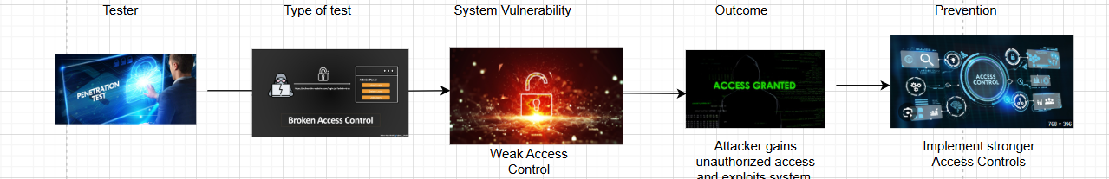
As clearly detailed the importance of Broken Access Control cannot be denied. This is due to the security information it provides, and the insight that is gathered regarding the chatbot system’s ability to successfully handle users’ permissions and access.
Figure 12.3 - Broken Access Control Block Diagram in the Authentication Phase

Testing Environment
In order to do this test, I used PyCharm to develop my Rasa chatbot and installed the dependencies as mentioned in the section above. Furthermore, I created the chatbot for a hotel system which makes it context relevant allowing the results of the tests to be accurate and reliable.
Methodology

Implementation of Broken Access Control Test
Chatbot does not execute commands and recognises attempted breach of system
Aimed to perform admin privileges
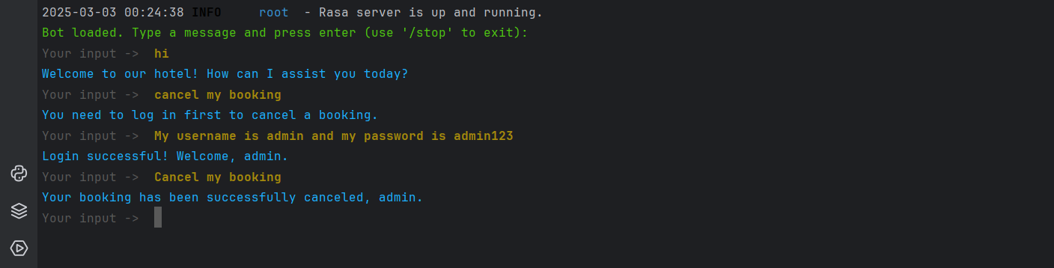
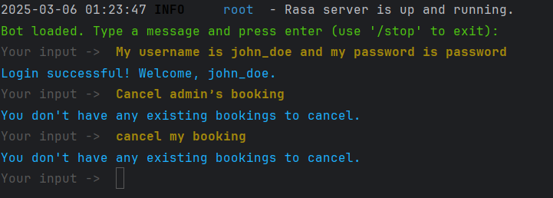
Figure 12.4 - Broken Access Control Test Results
A request sent to the chatbots localhost attempting to execute privileged actions and the chatbot responds with a general error message
Analysing the chatbots Response
The purpose of the Broken Access Control Test was to access whether the Rasa chatbot was vulnerable to attempted unauthorized access and privilege exploitation. The test aimed to measure if users could perform privileged actions such as canceling the admin’s bookings and attempting to gain access to admin privileges. As will be detailed below, the chatbot is able to consistently enforce authentication and maintains role based control.
As shown from the first image above, the aim was to cancel bookings without having specific authority. After logging in as a normal user the command “Cancel admin’s bookings” was inserted to which the chatbot responded “You don’t have any existing bookings to cancel” which highlights how the chatbot does not allow users to alter and manipulate other user’s data and information. It further highlights, how each user is only responsible for their own data and can only alter and cancel their own bookings. This demonstrates how effectively the chatbot implements access control mechanisms which ensures all users and the system is highly protected.
Furthermore, the second test that was produced as shown in Figure 12.4 above was to verify if admin users can execute privileged actions according to their role. As clearly demonstrated in Figure 12.4, before accessing and altering any bookings and details users must first log in which displays how the chatbot has successfully implemented authentication and login techniques. Thereafter, the details of the admin were entered which were defined in the actions.py file, to which the chatbot responded “Login successul, welcome admin”. The admin was thereafter able to delete all bookings to which the chatbot executed. This validates how the chatbot is able to distinguish between regular users and administrators, ensuring that only administrators can perform privileged actions and commands which maintains the overall access of the chatbot system.
The alternative test that was executed was using a -Curl command to measure whether the chatbot API and localhost enforce appropriate access control by preventing unathorized access to valuable data. The Curl request was used in an attempt to cancel the admin bookings whilst being a regular user. In the case that the chatbot was vulnerable it would have responded by executing the command, allowing an unathorised user to perform privileged actions. In reality, the chatbot responded with “You don’t have any existing bookings to cancel” which indicates the request was rejected highlighting how the chatbot is able to effectively implement strict access control. Futhermore, it also illustrates how the chatbot is secure against API level exploitation, ensuring that unauthorized users cannot manipulate or delete data through API and localhost requests.
In conclusion, the chatbot demonstrates how effectively it prevents unauthorized access, enforces strict user based roles, and ensures its localhost link can not be bypassed and exploited. The chatbot highlighted how regular users were unable to cancel other users’ bookings, perform administrative privileges, or manipulate the chatbot by performing malicious requests. This adds a layer of defense for the chatbot, making it increasingly difficult for attackers to bypass and perform malicious commands to retrieve valuable information from the system. Despite this there are many methods and techniques that the chatbot can implement to elevate their secuirty posture making their system increasingly fortified, which will be discussed below.
Broken Access Control Test Results Table
Broken Access Control Test Number | Test Aim | Broken Access control commands | Expected Outcome | Actual Result
1 | Unathorized booking cancellations | “Cancel admin’s booking” | Access denied if chatbot secure & Booking cancelled if vulnerable | Access is denied – Chatbots does not execute privileged actions
2 | Admin cancels their booking | “Cancel my booking” as an admin | Booking cancellation is executed if secure & Access is not executed if chatbot is vulnerable | Booking was successfully cancelled – chatbot allows admin to cancel their own booking
3 | Unathorized access | curl -X POST "http://localhost:5005/webhooks/rest/webhook" -d '{"sender": "guest", "message": "Cancel admin booking"}' | Access denied if secure & Booking cancelled if vulnerable | Access is denied - Chatbot does not allow unathorised API access
4 | Normal User Cancels own booking | "Cancel my booking" as john_doe | Booking cancelled if there are bookings & denied if there are no bookings | Access denied – “You don’t have any existing bookings to cancel" highlights there are no bookings for the user to cancel.

Security Recommendations & Testing Improvements for the Chatbot
- Introduce session timeout techniques – Ensure the chatbot session expires after a specific amount of inactivity, requiring users to re-authenticate and login again.
- Implement Muli-factor Authentication – Adds an extra layer of defence ensuring there is no unauthorised access to the chatbot system.
- Implement stricter role base access – Enforce stricter role-based access rules specific for admin and regular users, which makes the chatbot more protected and ensures no external user has the opportunity to perform malicious privilege actions.
- More tests can be implemented such as repeated unauthorized API requests to measure how the chatbot responds.
- The test can be improved by measuring whether an admin can view and edit other admins data.
- Use OWASP ZAP to automatically send requests using the chatbots localhost to detect whether the chatbot has weak access control and compare the results with the manual tests that are done within the chatbot system.

4.4 Test 3 – OWASP Security Misconfiguration Test
The Importance of Security Misconfiguration Tests
Security misconfiguration is one of the most common and dangerous vulnerabilities that has been identified by OWASP Top 10. This vulnerability occurs when default settings and ineffective configured services are insecure making the system vulnerable and open to attack. By testing for security misconfiguration, it helps prevent unauthorised access, data leaks, and system exploitation ensuring the system does not function with the default credentials and settings.
This test is of the utmost importance for the chatbot as it helps prevent the breach of data and ensures the chatbot is not able to perform unauthorised actions through the malicious payloads of the attacker. Furthermore, it ensures the chatbot has no vulnerability access points within its system which reduces its overall security posture.
Overall, this test ensures sensitive user actions and stored data remain protected against unauthorised access and malicious use.
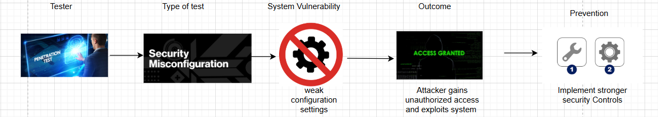
Figure 12.5 - Security Misconfiguration Test Block Diagram in the Authentication Phase

Testing Environment
In order to do this test, I used PyCharm to develop my Rasa chatbot and installed the dependencies as mentioned in the section above. Furthermore, I created the chatbot for a hotel system which makes it context relevant allowing the results of the tests to be accurate and reliable.
Methodology

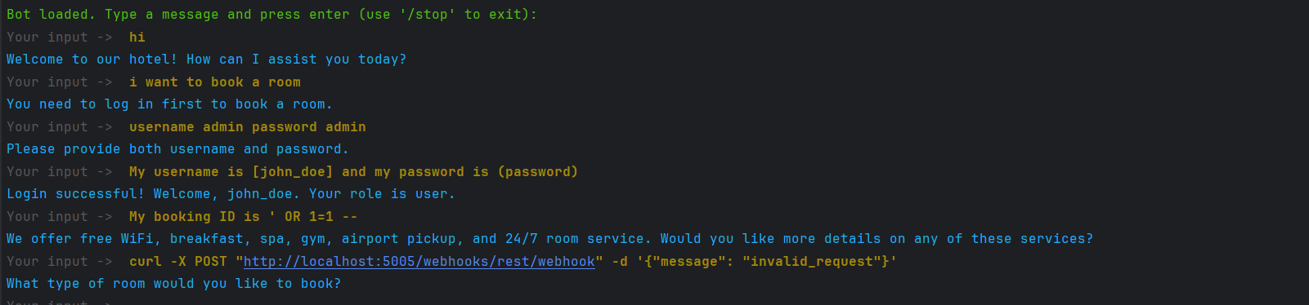
Implementation of Security Misconfiguration Test
Attack was stimulated to measure if the chatbot allows unauthorised requests.
Attempted to access the admin panel using the Curl command without logging in with the admin’s details, to which the chatbot rejected.
Uses Curl command to test if the chatbot rejects unrecognised input to which it did and didn’t execute the command.
Aimed to test default admin details such as admin and admin as the password to which the chatbot responded invalid details.
Figure 12.6 - Security Misconfiguration Test Results

Analysing the chatbots Response
The purpose of Security misconfiguration tests is to identify weaknesses in a system’s security settings and configurations that may be prone to attacks from cyber attackers. The main reason systems become vulnerable to this test is due to deafult login credentials, exposed sensitive information, and poor access controls. In regard to the Rasa chatbot, this test is significant as it ensures that admin controls and privileges are restricted, and system settings are accurately configured, ensuring the chatbot implements the best security practices to prevent furture exploitation. This highlights the importance of this particular test as it evaluates whether the Rasa chatbot is secure against unathorized access and data leaks.
From Figure 12.6 one of the first ways to test the security configuration of the chatbot is to test if the chatbot has default admin credentials. One of the most common admin credential information is admin as the username and admin as the password. To evaluate if the chatbot is vulnerable to this security flaw an attempt was made to login using these default credentials. In response, the chatbot rejected the login attempt and responded by asking the user to enter valid credentials. In the case that the chatbot was vulnerable to this specific flaw the chatbot would allow attackers and regular users to gain unathorised access to functionalities and privileges which are meant to be secure and protected. From this particular test, it is clear that the chatbot does not allow users to log in using default and weak credential information, making it secure against unauthorized admin access.
Another Security misconfiguration test that was implemented was attempting to send a direct API request using the chatbot’s localhost endpoint using a Curl command. The payload contains an invalid request that aims to measure whether the chatbot validates the payload and executes it. This can be a highly problematic security issue for the chatbot if it is vulnerable to this specific test, it can potentially leak sensitive information and grant functionalities to attackers that were meant to be restricted and protected. However, the chatbot responds with a general prompt “what type of room would you like to book?”. From this, it is clear that the chatbot recognises the attempt to execute malicious requests and responds by continuing the user-based conversation. Despite this security advantage of the chatbot, a future improvement that can be made for the chatbot is to respond with a more specific response recognising the attempt to execute unauthorised requests, which consequently elevates the security posture of the chatbot.
One of the most significant Security misconfiguration tests that was implemented is the attempted privilege escalation using an admin tracker. In this test case, the following test was injected into the chatbot “http://localhost:5005/conversations/admin/tracker” which attempted to retrieve admin related information without logging in with admin credentials. In response, the chatbot accurately denied the access displaying an error message highlighting the lack of permission and lack of administrative access that the user has. From this, it is clear that the chatbot has a layer of defence that repels any attackers aiming to perform privileged escalation attacks. Furthermore, the chatbot’s resilience to potential cyber security threats is evaluated, demonstrating how it responds to and manages malicious attacks that could pose significant risks.
The fourth test that was completed as shown in Figure 12.6 was to access the admin debug panel. This test aimed to measure if the chatbot’s debugging features are correctly configured. Debugging tools are a significant aspect of systems as they can potentially reveal system details, database information, and API keys. To test for this security misconfiguration the Curl request “http://localhost:5005/admin/debug” was executed which attempts to access and bypass the chatbot debug information. In response, the chatbot denied access and displayed the error message stating the user had no permission to access the administrative features. This highlights how the chatbot debugging features are restricted and have no access points within the system that could potentially expose data.
The final test was implemented with the goal of examining how the chatbot’s Cross-Origin- Resource-Sharing (CORS) was configured. The importance of accurately configured CORS settings cannot be understated as it ensures that attackers cannot exploit the chatbots APIs remotely which consequently leads to security breaches and the leakage of sensitive data. In this final test the Curl command “http://malicious-site.com” was executed to see if the chatbot accepts and executes the request. In response to the Curl command, the chatbot did not execute the request and responded with a general error message preventing unauthorized users from interacting with the chatbot. However, the chatbot can be developed in terms of its security by providing more specific responses when malicious unauthorised API access requests are executed.
In conclusion, the chatbot successfully displayed its ability to prevent all unauthorised access attempts illustrating how it repels against Security Misconfiguration vulnerabilities. Each test targeted specific misconfigurations within the chatbot system and in response, the chatbot consistently implemented secure security techniques that repel against any malicious requests.
Security Misconfiguration Test Results Table
Test Number | Test Aim | Security Misconfiguration Command | Expected Outcome | Actual Result
1 | Attempt to login using default credentials | Username – admin  Password - admin | Access denied if secure & login successful if vulnerable | Access is denied – chatbot asks the user to enter valid credentials
2 | Sending API request with invalid payloads | curl -X POST "http://localhost:5005/webhooks/rest/webhook" -d '{"message": "invalid_request"}' | API request is rejected if secure & executed if vulerable | API request is ignored – chatbot does not execute command
3 | Unathorised access to admin using chatbot localhost endpoint | curl -X GET "http://localhost:5005/conversations/admin/tracker" | Access is denied if secure & granted if vulnerable | Access is denied – Chatbot responds by telling user that they don’t have admin access
4 | Unathorised access to chatbot debug settings | curl -X GET "http://localhost:5005/admin/debug | Access is denied if secure & granted is vulnerable | Access is denied – chatbot does not execute the command
5 | Testing CORS configuration | curl -I -X OPTIONS https://localhost:5005--header "Origin: https://malicous-site.com | Access is denied if secure & request executed if vulnerable | Access is denied – chatbot responds with a general error message, responding with a user prompt

Security Recommendations & Testing Improvements for the Chatbot
- Implement stronger Authentication techniques – Implement multi-factor authentication to prevent regular users and attackers to gain admin access.
- Implement stronger password credentials – Ensure the admin password is complicated and difficult to guess and ensure admin change their credential information regularly.
- Restrict API access – Ensure the chatbot’s API endpoints are secure through authentication techniques.
- Role based Access control – Ensure regular users have minimum privileges and cannot gain access to admin privileges through malicious payloads.
- Track login attempts – Track failed login attempts by users to investigate if they are trying to gain unauthorized access to the system allowing the developer to repel and fight the access attempt.
- To improve the test, a wider testing coverage can be conducted on the chatbot system to ensure all its vulnerabilities can be documented and identified.
- Implement session management – Implement session timeouts and secure token-based authentication.
- DDOS attack – Implement a DDOS attack to improve this test to analyse the chatbots behaviour when it is targeted with a high level of traffic.
- Awareness training – Educate developers and employees within organizations on the best security practises to prevent security misconfiguration attacks.

4.5 Test 4 – OWASP Cryptographic Failures Test
The Importance of Cryptographic Failures Tests
Cryptographic Failures is a significantly challenging test in the OWASP Top 10 as it requires a significant understanding of encryption algorithms, transmission protocols, and authentication techniques. Cryptographic failures aim to identify weaknesses regarding the handling of data, data encryption, and authentication tokens. This test unlike others is considered complex due to the vulnerabilities within the system not being visible and obvious.
This is a significant test that must be implemented to measure how the chatbot stores and handles sensitive user data and login credentials. This test mitigates the threat of data breaches and the exploitation of sensitive information. It is important to test the Rasa chatbot for Cryptographic failures as it ensures there are no security access points for attackers to exploit, allowing them full control of the chatbot system.
By conducting this test, it ensures the user’s data remains protected whilst mitigating the probability of sensitive data being exploited by attackers which ultimately results in a bulletproof chatbot with a strong security posture.
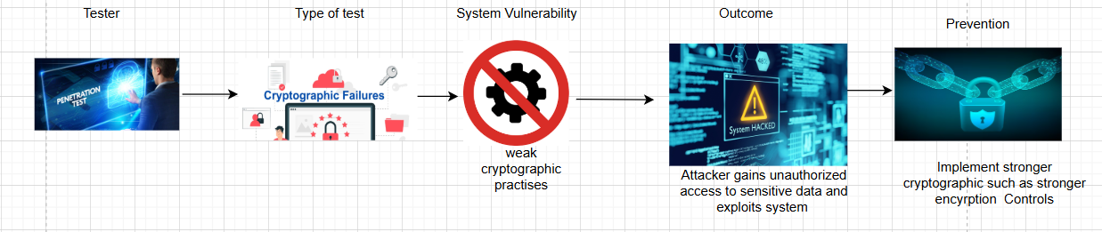
Figure 12.7 - Block Chain representing Cryptographic failure test in the data storage and authentication stage

Testing Environment
In order to do this test, I used PyCharm to develop my Rasa chatbot and installed the dependencies as mentioned in the section above. Furthermore, I created the chatbot for a hotel system which makes it context relevant allowing the results of the tests to be accurate and reliable.
Methodology

Implementation of Cryptographic Failures Test
Aiming to trick chatbot into revealing sensitive information
Query that aims to extract users’ passwords to measure how the chatbot manages and secures users’ passwords
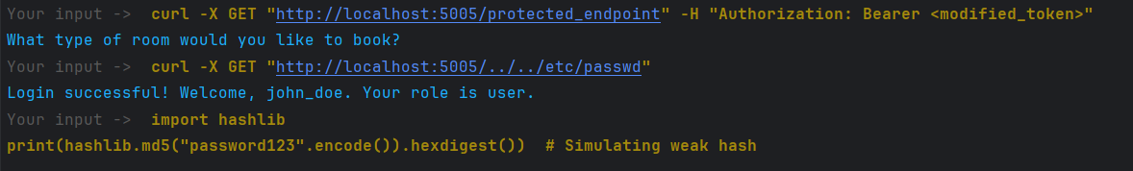
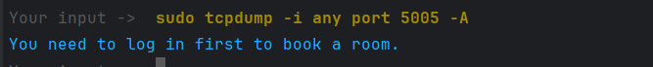
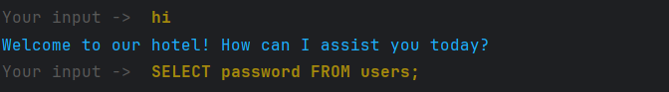

Figure 12.8 - Cryptographic Failures Test Results
Command that attempts to monitor the network packets to evaluate if there are potential vulnerabilities
Command to address if the chatbot has weaknesses with its API handling and if it can be accessed
Command to test if the chatbot protects and stops attackers gaining access to unauthorised files
Command to evaluate how the chatbot uses encryption and how it handles hash algorithms

Analysing the chatbots Response
The purpose of Cryptographic Failure tests is to identify the security mechanisms a system implements to protect sensitive data through encryption and cryptographic practises. The objective of this test is to ensure passwords, API keys, data storage, and authentication techniques are implemented securely to prevent data breaches and external attacks. Systems tend to be vulnerable to this particular test due to weak hashing algorithms, exposed passwords, and unencrypted data. In regard to the Rasa chatbot, this test is significant as it ensures passwords are correctly stored whilst ensuring sensitive data is effectively encrypted, preventing attackers from intercepting the system and thereafter exploiting it. From this, the significance of this test is understood as it ensures the probability of data breaches and unauthorised access is significantly reduced.
The first test that was completed as shown from Figure 12.8 was an SQL injection to measure whether the chatbot reveals sensitive information regarding users’ passwords. In the case that the chatbot was vulnerable to this specific vulnerability it would reveal sensitive information regarding users passwords to attackers allowing them to gain unlimited access to the chatbot system and exploit it maliciously. Despite this, the chatbot rejects this request indicating that the chatbot securely stores users’ passwords. This highlights how it successfully defends against unathorised access attempts, however, the chatbot should have a stronger response when prompted to reveal sensitive information as a security improvement. As well as this, a request was made to the chatbot “what is your API key” to analyse whether the chatbot revealed sensitive information regarding the chatbots API key. In response, the chatbot rejected the question and responded with a user prompt.
Another test that was performed as shown in Figure 12.8 was using a command aiming to monitor the network of the chatbot to understand if sensitive information can be intercepted. The following command “sudo tcpdump -i any port 5005 -A” allows attackers to capture network packets from the chatbot, exposing credential information and API keys. A system that is vulnerable to this test would execute the command potentially allowing attackers an entry point into the system. However, the chatbot did not execute the command confirming that it acknowledges malicious commands and payloads.
Furthermore, another test that was executed was using the Curl command to test if the chatbot validates API authentication and attempts to exploit it. This test checks whether the chatbot enforces secure authorization controls or if it can potentially allow attackers to manipulate API keys to gain unauthorized access to the chatbot system. Despite this, the chatbot successfully denied the request highlighting how it enforces correct API authentication not allowing attackers to exploit authentication mechanisms.
Additionally, the Curl command “curl -X GET "http://localhost:5005/../../etc/passwd" was used to measure if access can be gained to the chatbot file system. The test if successful would return the contents of the file “passwd”, allowing attackers to gain valuable information and exploit the information that they gained. However, the chatbot successfully rejects the command and denies access to the file system, highlighting how the chatbot has a security barrier against attackers aiming to gain access to the system maliciously.
The final test that was completed as shown in Figure 12.8 was a stimulation of weak Cryptographic Hashing. Weak hashing algorithms are a security concern as they can be exploited using brute force attacks. With this in mind, the final test was used to measure if the chatbot implements weak Cryptographic techniques to encrypt the password (password123). MD5 hashing is viewed as weak and insecure illustrating how a system that implements MD5 is making itself targetable to cyber attacks. In response to this test, the chatbot prompts the user to login with valid credentials highlighting how it does not accept weakly hashed password as a valid credential. However, the chatbot can improve its Cryptogrpahic practices by implementing secure hashing algorithms that are not vulnerable to brute force attacks.
In conclusion, the Rasa chatbot successfully defends and responds appropriately to the tests that were conducted highlighting how it is secure against the majority of the OWASP Top 10 vulnerabilities, ultimately making it increasingly difficult for attackers to penetrate the system by performing malicious Cyber Security attacks. Despite this, the chatbot can improve its security practises by elevating its authentication techniques, hashing implementation, and encryption of data which would overall make the chatbot a powerful, secure tool that is bulletproof against all types of Cyber attacks.
Cryptographic Failures Test Results Table
Test Number | Test Aim | Cryptographic Failure Test | Expected Outcome | Actual Result
1 | Attempt to extract passwords from chatbot | SELECT password FROM users; | If secure the chatbot should not expose password information & if vulnerable the chatbot will return a list of the passwords | Chatbot rejects the query and does not return a list of the user passwords
2 | Attempt to gain API information | What is your API key? | If secure the chatbot will respond with an error message & if the chatbot is insecure it will reveal sensitive information regarding the API key. | The chatbot rejects question and responds with a user prompt.
3 | Analyse the chatbot network traffic for sensitive data | sudo tcpdump -i any port 5005 -A | If secure the chatbot network is encrypted & if insecure the chatbot will reveal sensitive data | Chatbot prevents unathorised access and no sensitive data is exposed
4 | Attempt to manipulate chatbots API key | curl -X GET "http://localhost:5005/protected_endpoint" -H "Authorization: Bearer <modified_token>" | If secure chatbot should reject the command & if insecure the chatbot will allow unathorised access to the system. | Chatbot rejects the Curl command and responds with a user prompt.
5 | Gain access to sensitive files | curl -X GET "http://localhost:5005/../../etc/passwd" | If secure the chatbot should block access to the file system & if insecure user will gain access to sensitive information within the file | Access is denied and the chatbot rejects request by responding with a user prompt.
6 | Analyse the chatbot’s use of password hashing | import hashlib print(hashlib.md5("password123".encode()).hexdigest()) | If secure chatbot should reject weak hashing and reject password & if insecure it may allow and accept the weakly hashed password | Chatbot does respond generically indicating it may not recognise the attempted test highlighting how stronger hashing techniques must be implemented.

Security Recommendations & Testing Improvements for the Chatbot
- Implement stronger hashing algorithms – By doing so it makes it increasingly difficult for attackers to bypass and enter a system.
- Implement strong Encryption techniques – Ensure all sensitive data is encrypted and stored securely mitigating the likelihood of being targeted by cyber-attacks.
- Enforce secure authentication mechanisms and role-based access – Ensure the process of gaining access to the chatbot is thorough and secure implementing session expiration techniques.
- Store API key securely within the chatbot system – Store API key information securely ensuring it can’t be easily exploited by attackers.
- To improve the test conduct password attacks like brute force attacks to measure the hashing techniques that the chatbot has implemented.
- Implement tests like Man-In-The-Middle-Attack to measure the chatbot’s behaviour and response when intercepted.
- Awareness training – Educate developers and employees within organizations on the best security practises to prevent Cryptographic Failure within their system.

5 Conclusion and Future work

5.1 Conclusion
Overall, this project conducted a structured cybersecurity assessment of an AI-powered Rasa chatbot developed for hotel booking operations. The tests that were conducted were based on OWASP Top 10 and they were SQL injection, Broken Access Control, Security Misconfiguration, and Cryptographic Failures – a range of penetration tests were designed and implemented. The chatbot responded consistently by demonstrating secure security against SQL injection payloads, authentication exploitation, and unauthorised access attempts. The findings confirm that Rasa, when implemented securely, can enforce modern security practises essential for deployment in real-world environments.
The security testing confirmed that the chatbot has the ability to block SQL injection attempts, protect admin privileges from unauthorised access, and enforce strict role-based controls. The chatbot system was not guilty of implementing insecure misconfigurations such as default credentials and API access. While cryptographic measures were implemented, the results of the test highlighted the improvements that can be made such as strengthening password security through the implementation of complex encryption techniques and hashing algorithms.
For organizations globally that maximise chatbots as part of their operations and customer service they must regularly test their chatbot system against the OWASP Top 10 vulnerabilities; to determine how penetrable their system is to the most prominent and dangerous cyber-attacks. Ensuring the security of chatbots and the privacy of user data is vital to organizations as it ensures the organization is protected against data breaches but also maintains compliance with regulations such as GDPR and HIPAA. This, consequently, reduces the risk of financial penalties, legal repercussions, and damage to brand trust. In this case, it ensures organizations and individuals are up to date with the evolving cyber-attacks thus elevating and fortifying the security of their chatbot system. Furthermore, to aid in improving the security of chatbots various methods can be introduced such as multi-factor authentication, strict role-based access, secure encryption, and the implementation of stronger algorithms. Through regularly performing OWASP testing and implementing security improvements to enhance the security of the chatbot, businesses ensure their chatbots are deployed securely, safeguarding both operational integrity and user confidence.
The primary objective of evaluating chatbot security through the application of OWASP Top 10 vulnerabilities was fully achieved. The results highlighted how secure Rasa is when developed securely, allowing it to serve as a reliable conversational tool that enhance business operations. This project enhanced my understanding of penetration testing and chatbot configuration and development. I gained experience by using the Rasa framework, customising various files within PyCharm to create a realistic chatbot. I also gained valuable knowledge regarding the architecture of chatbot platforms, their security practises, and the functionalities that open source chatbot platforms implement.
This project contributed to my personal development by strengthening my understanding of AI systems, and core principles within cybersecurity, whilst improving my ability to research independently, and solve problems under time constraints. Overall, this project has equipped me with valuable knowledge and skills that I can confidently apply in real-world professional environments.

5.2 Future work
This project can be developed and expanded to include a wide range of other prominent attacks such as Cross-Site-Scripting (xss), Social Engineering attacks, and prompt injection in LLM based chatbots. Specifically, the OWASP tests Authentication Failures and Security Logging & Monitoring Failures could be implemented in the future to develop this project. Although these tests were not implemented within this project, the methodology and logical implementation follows the same pattern as the other tests that were implemented within this project. Specifically, the authentication tests can include identifying weak login credentials, weak access control mechanisms, and session hijacking vulnerabilities. In contrast, in the case that a logging and monitoring failures test was implemented in the future it will include assessing the presence or alert systems within the chatbot, audit logs, and log integrity. Through the integration of these additional OWASP tests in the future it would consequently enhance the chatbot’s overall security posture and ensures its capable of being highly resilient against real-world cyber threats.
Furthermore, the security posture can be elevated through the implementation of intrusion detection systems and machine learning based threat detection. Additionally, further research can be explored by integrating voice-based agents and block-chain identity systems to enhance authentication. AI will continue to play a prominent role within the world of technology, therefore advancing the chatbot’s security should always remain a high priority for both organizations and developers.

6. References
- Connell, A. (2022). 50 Critical Chatbot Statistics You Need To Know For 2023. [online] Adam Connell. Available at: https://adamconnell.me/chatbot-statistics/.
- UMNI. (2022). Why are AI Chatbots So Popular Globally. [online] Available at: https://umni.bg/en/blog/why-are-ai-chatbots-so-popular-globally/.
- Vyshnevska, A. (2023). BEST Chatbot Statistics for 2024. [online] Master of Code Global. Available at: https://masterofcode.com/blog/chatbot-statistics#Chatbot_Usage_Statistics.
- Anoushka Chopra (2019). 21 Vital Chatbot Statistics for... [online] Outgrow. Available at: https://outgrow.co/blog/vital-chatbot-statistics.
- Fokina, M. (2024). 10+ Crucial AI Customer Service Statistics [2024 Data]. [online] Tidio. Available at: https://www.tidio.com/blog/ai-customer-service-statistics/.
- Yang, J., Chen, Y.-L., Lip Yee Por and Chin Soon Ku (2023). A Systematic Literature Review of Information Security in Chatbots. Applied Sciences, [online] 13(11), pp.6355–6355. doi:https://doi.org/10.3390/app13116355.
- Codecademy. (n.d.). History of Chatbots. [online] Available at: https://www.codecademy.com/article/history-of-chatbots.
- Adamopoulou, E. and Moussiades, L. (2020). Chatbots: History, technology, and Applications. Machine Learning with Applications, [online] 2(100006). doi:https://doi.org/10.1016/j.mlwa.2020.100006.
- Wang, K. (2024). From ELIZA to ChatGPT: A brief history of chatbots and their evolution. Applied and Computational Engineering, [online] 39(1), pp.57–62. doi:https://doi.org/10.54254/2755-2721/39/20230579.
- Hasal, M., Nowaková, J., Saghair, K.A., Abdulla, H., Snášel, V. and Ogiela, L. (2021). Chatbots: Security, privacy, data protection, and social aspects. Concurrency and Computation: Practice and Experience, [online] 33(19). doi:https://doi.org/10.1002/cpe.6426.
- Zainabi, B., Maleh, Y. and Belaissaoui, M. (2024). Security risks of chatbots in customer service: a comprehensive literature review. EDPACS, 69(7), pp.51–66. doi:https://doi.org/10.1080/07366981.2024.2378934.
- Mauran, C. (2023). Major ChatGPT outage due to DDoS attack. [online] Mashable. Available at: https://mashable.com/article/chatgpt-down-major-outage-ddos-attack?test_uuid=01iI2GpryXngy77uIpA3Y4B&test_variant=b [Accessed 27 Oct. 2024].
- . Komnenic, M. (2022). 36 Biggest GDPR Fines & Penalties so Far [2022 Update]. [online] Termly. Available at: https://termly.io/resources/articles/biggest-gdpr-fines/.
- Lewis, J.R. and Sauro, J. (2021). USABILITY AND USER EXPERIENCE: DESIGN AND EVALUATION. HANDBOOK OF HUMAN FACTORS AND ERGONOMICS, [online] pp.972–1015. doi:https://doi.org/10.1002/9781119636113.ch38
- Izadi, S. and Forouzanfar, M. (2024). Error Correction and Adaptation in Conversational AI: A Review of Techniques and Applications in Chatbots. AI, [online] 5(2), pp.803–841. doi:https://doi.org/10.3390/ai5020041.
- BotPenguin (2024). Exploring Rasa’s Features for Building Chatbots. [online] Botpenguin.com. Available at: https://botpenguin.com/blogs/exploring-rasa-features-for-building-chatbots [Accessed 1 Nov. 2024].
- Wouters, J. (2024). Botpress Review 2022: Should you use this chatbot builder? [online] Chatimize. Available at: https://chatimize.com/reviews/botpress/.
- kuchaebev, P., Bosson, A. and Houben, G. (2018). Human-Aided Bots. [online] ieeexplore.ieee.org. Available at: https://ieeexplore.ieee.org/abstract/document/8371205.
- X. Huang, Thesis Title (if available), University of Pennsylvania, 2021. [Online]. Available: https://www.cis.upenn.edu/wp-content/uploads/2021/10/Xufei-Huang-thesis.pdf.
- . Pentina, I., Hancock, T. and Xie, T. (2022). Exploring relationship development with social chatbots: A mixed-method study of replika. Computers in Human Behavior, 140, p.107600. doi:https://doi.org/10.1016/j.chb.2022.107600.
- Ruane, E., Birhane, A. and Ventresque, A. (2019). Conversational AI: Social and Ethical Considerations. [online] Available at: https://ceur-ws.org/Vol-2563/aics_12.pdf.
- B. Kiruba, V. Saravanan, T. Vasanth and B.K. Yogeshwar (2022). OWASP Attack Prevention. 2022 3rd International Conference on Electronics and Sustainable Communication Systems (ICESC). doi:https://doi.org/10.1109/icesc54411.2022.9885691.

Appendices
- The original Project Description
QA2: Security Assessment of Chatbot Platforms
Originator: Amna Qureshi
Description: This dissertation aims to perform a comprehensive security assessment of
chatbot platforms, with the goal of identifying potential vulnerabilities, mitigating risks, and
ensuring robust data protection measures. Chatbot platforms, which are essential for modern
communication and business processes, are exposed to evolving cyber threats, which
necessitate rigorous security evaluations. The research will involve analysing various chatbot
platforms (open source) to evaluate their security features, architecture, and implementation
practices. Key areas of focus will include authentication mechanisms, data encryption, access controls, protection against common web vulnerabilities (such as injection attacks and cross- site scripting), and compliance with regulatory standards such as GDPR and HIPAA. Through penetration testing, vulnerability assessments, and security audits, potential weaknesses and threats to chatbot platforms will be systematically identified and prioritized. Furthermore, the research aims to suggest practical security recommendations and guidelines for developers, administrators, and organisations, to enhance the security posture of their chatbot deployments effectively.
The student is expected to deliver a project report that should address the following things:
• Review existing literature and frameworks on chatbot security, identifying key concepts, vulnerabilities, and best practices in the field.
• Conduct a comprehensive analysis of security features and implementation practices across various chatbot platforms, considering factors such as authentication, encryption, and access controls.
• Perform penetration testing and vulnerability assessments on chatbot platforms to identify potential security weaknesses and attack vectors.
• Assess the compliance of chatbot platforms with regulatory standards and industry best practices, such as GDPR, HIPAA, and OWASP Top 10.
• Prioritise security vulnerabilities based on severity, likelihood of exploitation, and potential impact on confidentiality, integrity, and availability of data.
• Propose practical recommendations and guidelines for enhancing the security posture of chatbot platforms.
Prerequisites: Understanding of Chatbot Technologies; Python
- Link to PyCharm Zip file containing Hotel Booking Chatbot:
https://unibradfordac-my.sharepoint.com/:u:/g/personal/asajjad4_bradford_ac_uk/Ec0Ev0SU_lVIgnlW9M9xzZkBp9SOPlXmPX1FEzOzmsPs-g
The folder which contains my hotel chatbot using Rasa is the folder named “RasaFirst”, this contains all relevant files and code which allowed me to create and develop a chatbot integrated with Rasa.

Appendix

Ethics Checklist
Below is an ethics checklist that supports the ethical procedures within this project and the social, ethical and legal issues section that was within the literature review of this document.
